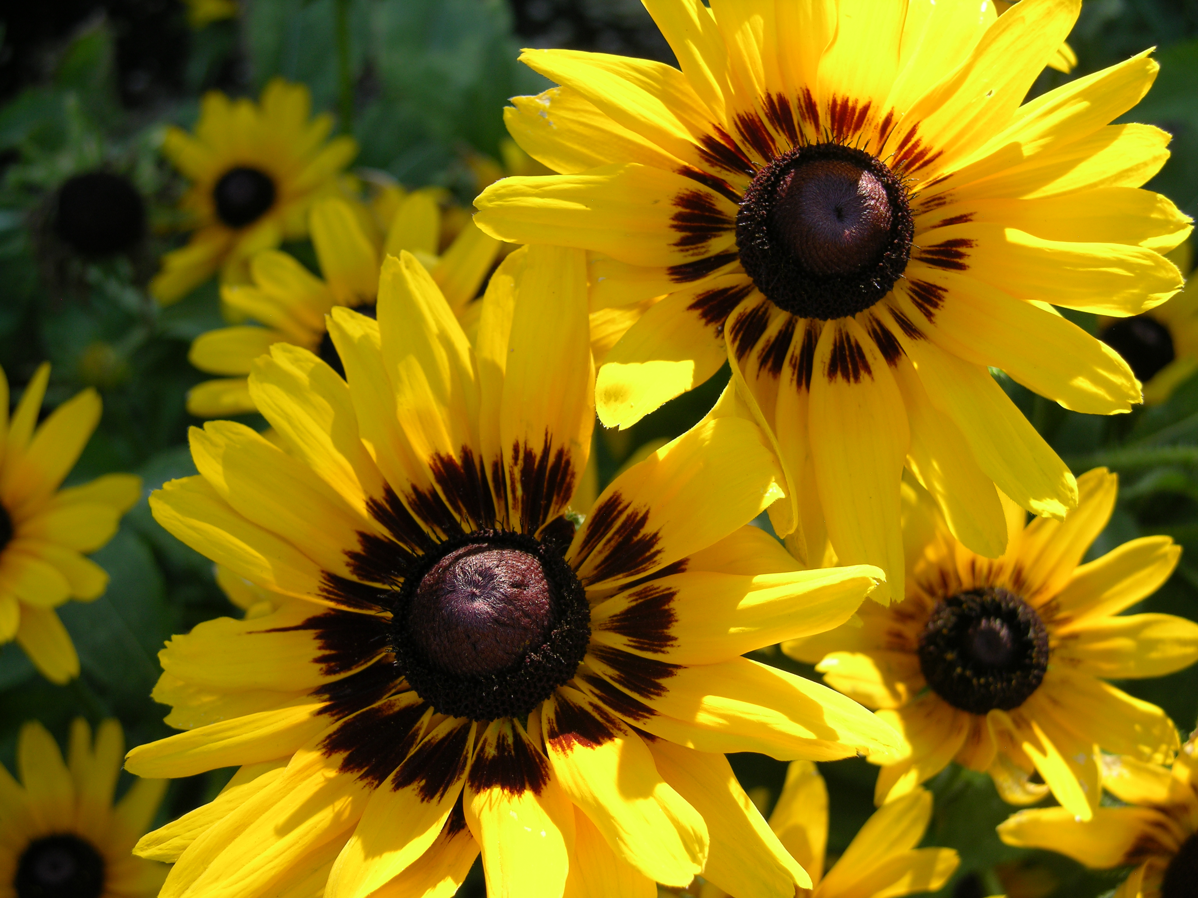

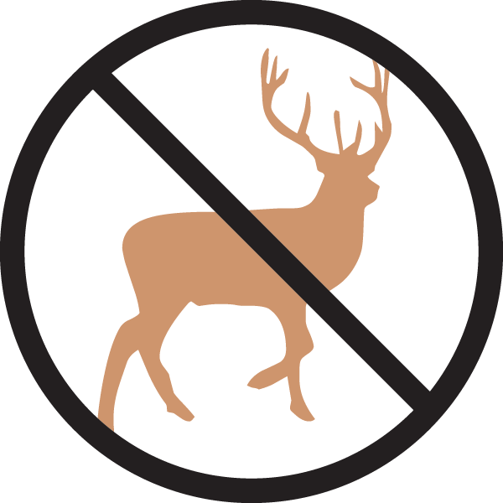

Height: 18-28”
Width: 10-25”
Blooms: May to late summer
Sun: Full sun to partial shade
Water: Moderate to dry
Hardiness: USDA zones 3-9 (up to 9,000’)
Culture: Clay, loam or gravelly soil
Introduced: 2009
Tender Perennial
Striking dark eyed, long-rayed daisy, hybridized, by Benary from the Colorado native Black-Eyed Susan (Rudbeckia hirta). This showy plant commemorates the 150th anniversary of the founding of Denver.

Denver Daisy ™
Rudbeckia
www.plantselect.org

