
Denver Daisy ™
Rudbeckia

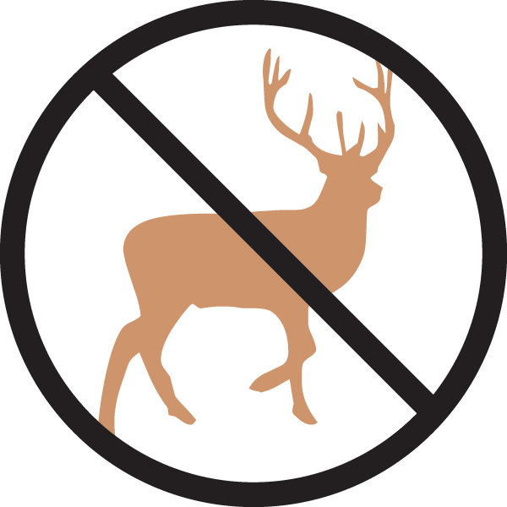
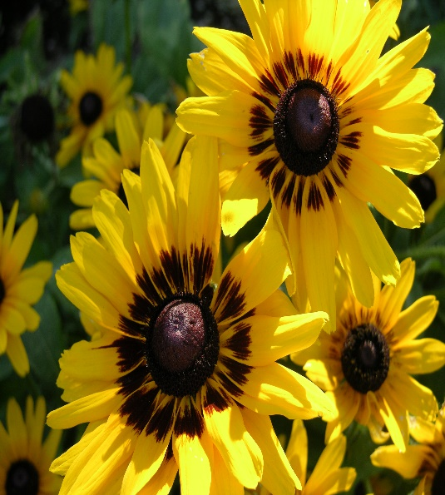




Height: 18-28 in. Width: 10-25 in.
Striking dark eyed, long-rayed daisy, hybridized, by Benary from the Colorado native Black-Eyed Susan (Rudbeckia hirta). This showy plant commemorates the 150th anniversary of the founding of Denver.
Culture: Gravelly, clay or loam soil
Hardiness: USDA zones 6-9



WIND. HAIL. SNOW. SUN
BRING IT ON

www.plantselect.org



