


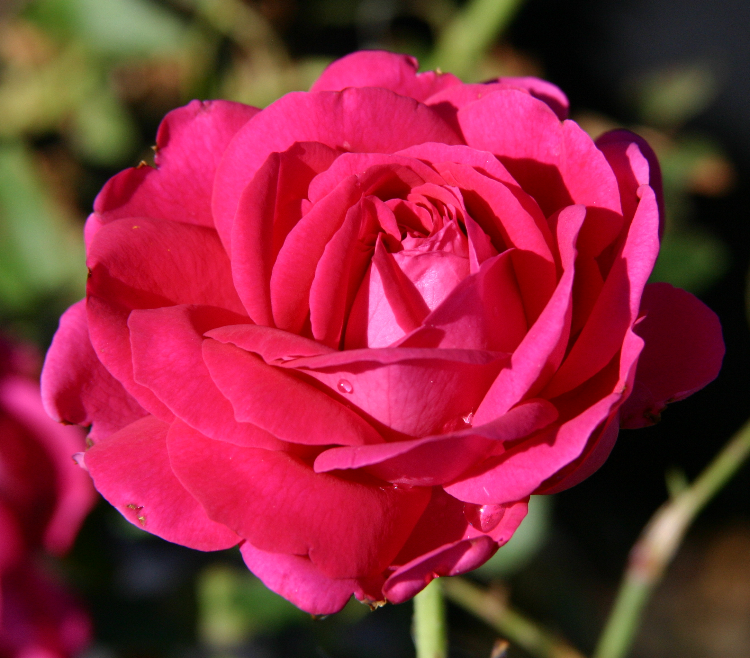
Height: 5-6’
Width: 4-5’
Blooms: May to July
Sun: Full sun to partial shade
Water: Moderate
Hardiness: USDA zones 4-10 (up to 8,000’)
Culture: Sandy, clay, or loamy soils
Introduced: 2012
Shrub
Spectacular late spring blooms with multi-toned, purple-pink double blossoms repeat moderately through the summer. Intensely fragrant, its attractive habit and vigor will ensure that this John Starnes hybrid becomes a staple in the new American rose garden. Annual pruning encourages a more compact habit.

Ruby Voodoo Rose
Rosa ‘Ruby Voodoo’
www.plantselect.org

