
Ruby Voodoo Rose
Rosa ‘Ruby Voodoo’






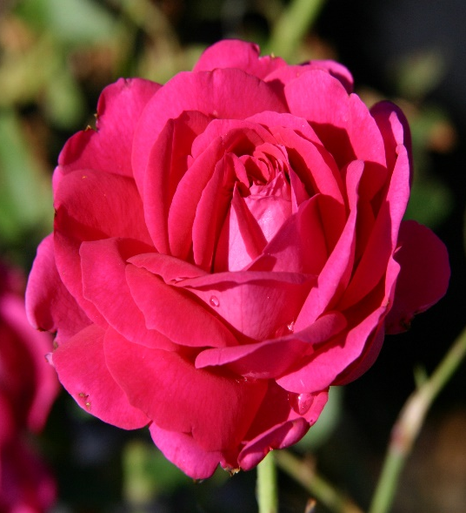

Height: 5-6 ft. Width: 4-5 ft.
Spectacular late spring blooms with multi-toned, purple-pink double blossoms repeat moderately through the summer. Intensely fragrant, its attractive habit and vigor will ensure that this John Starnes hybrid becomes a staple in the new American rose garden.
Culture: Clay, loam or sandy soil
Hardiness: USDA zones 4-10



WIND. HAIL. SNOW. SUN
BRING IT ON

www.plantselect.org



