

**Ruby Voodoo Rose**

*Rosa* ‘Ruby Voodoo’

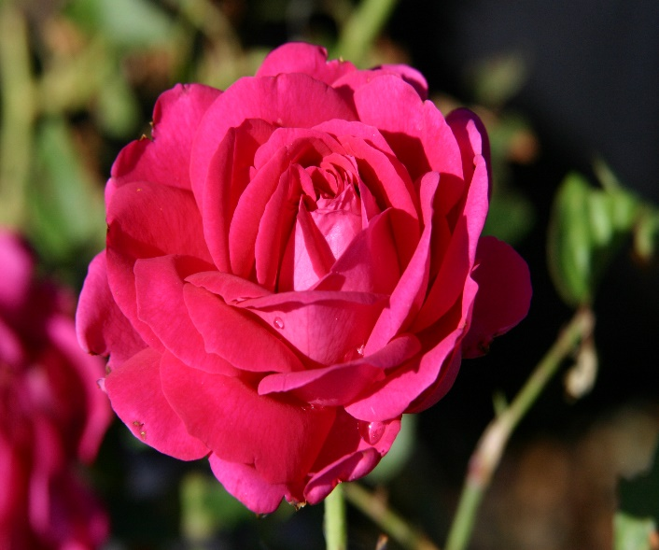

**Height: 5-6 ft. Width: 4-5 ft.**

Spectacular late spring blooms with multi-toned, purple-pink double blossoms repeat moderately through the summer. Intensely fragrant, its attractive habit and vigor will ensure that this John Starnes hybrid becomes a staple in the new American rose garden.

**Culture:** Clay, loam or sandy soil

**Hardiness:** USDA zones 4-10



WIND. HAIL. SNOW. SUN

**BRING IT ON**

www.plantselect.org

