
Redleaf Rose
Rosa glauca, R. rubrifolia








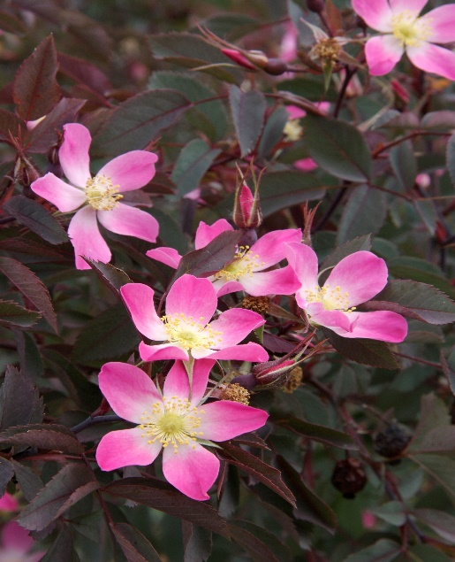

Height: 6-8 ft. Width: 4-6 ft.
The single rose blossoms range from a pleasing pastel pink to white from May to June. But this is a rose grown as much for the gorgeous red hips that persist much of the year, and its dark purple foliage color that provides a wonderful foil to the silvers and greens that dominate our xeriscapes.
Culture: Clay, loam or sandy soil
Hardiness: USDA zones 3-9



WIND. HAIL. SNOW. SUN
BRING IT ON

www.plantselect.org



