

**Redleaf Rose**

*Rosa glauca, R. rubrifolia*

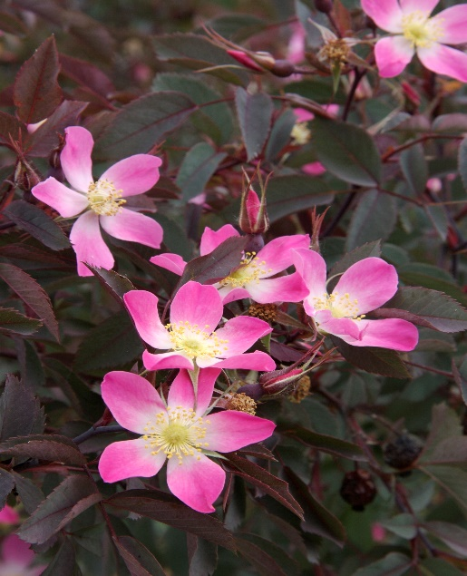

**Height: 6-8 ft. Width: 4-6 ft.**

The single rose blossoms range from a pleasing pastel pink to white from May to June. But this is a rose grown as much for the gorgeous red hips that persist much of the year, and its dark purple foliage color that provides a wonderful foil to the silvers and greens that dominate our xeriscapes.

**Culture:** Clay, loam or sandy soil

**Hardiness:** USDA zones 3-9



WIND. HAIL. SNOW. SUN

**BRING IT ON**

www.plantselect.org

