
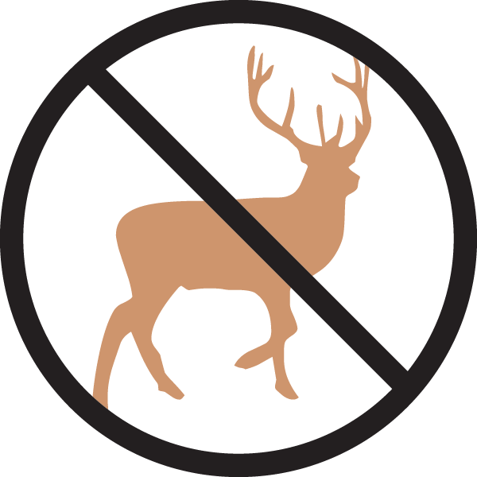


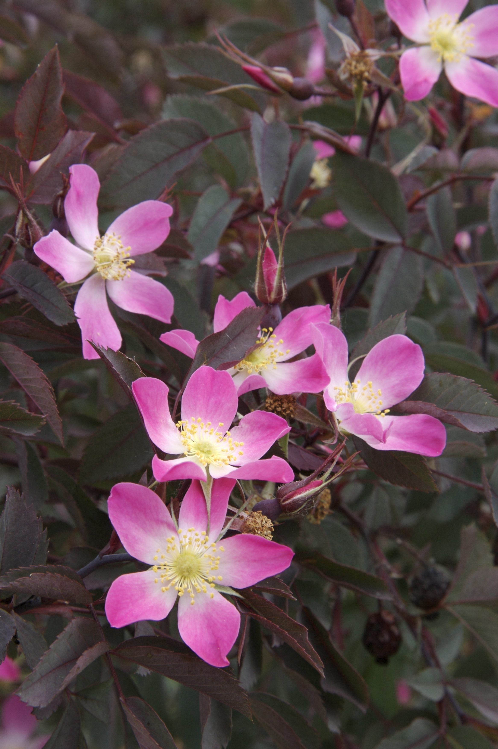
Height: 6-8’
Width: 4-6’
Blooms: May to June
Sun: Full sun to partial shade
Water: Moderate to dry; xeric
Hardiness: USDA zones 3-9 (up to 9,000’)
Culture: Clay, loam or sandy soil
Introduced: 2010
Medium-sized to Large Shrub
The single rose blossoms range from a pleasing pastel pink to white. But this is a rose grown as much for the gorgeous red hips that persist much of the year, and its dark purple foliage color that provides a wonderful foil to the silvers and greens that dominate our xeriscapes. This hardy blooming shrub thrives just about anywhere providing graceful presence with no effort, beautifying the dry garden all year round.

Redleaf Rose
Rosa glauca, R. rubrifolia
www.plantselect.org

