
Comanche Gooseberry
Ribes uva-crispa ‘Red Jacket’


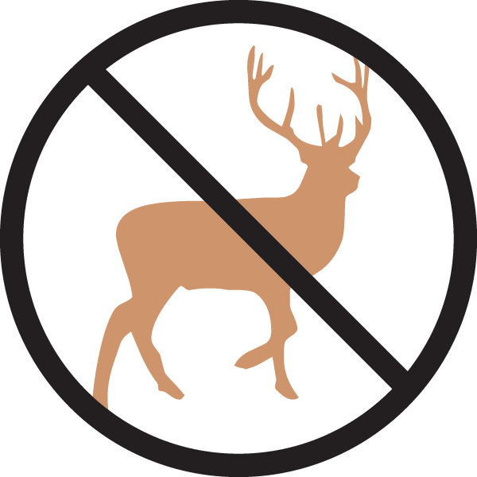
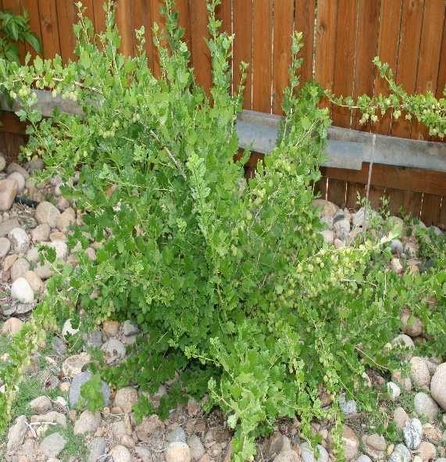




Height: 2.5 ft. Width: 5 ft.
Bright green leaves set off many clusters of sweet, huge, red berries in midsummer. Mounding plant with long thorns; good as a hedge. This is the original selection from England, not the selection from Canada. Powdery mildew resistant. Very hardy.
Culture: Clay, loam or sandy soil
Hardiness: USDA zones 3-9



WIND. HAIL. SNOW. SUN
BRING IT ON

www.plantselect.org



