
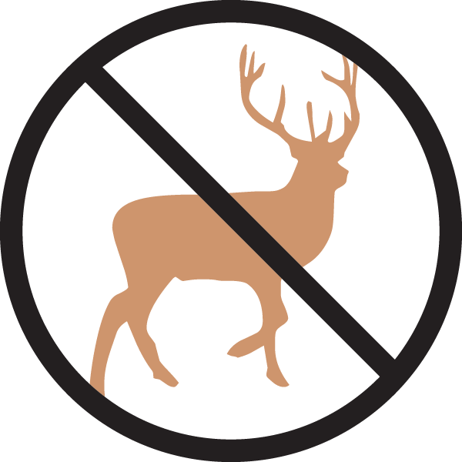


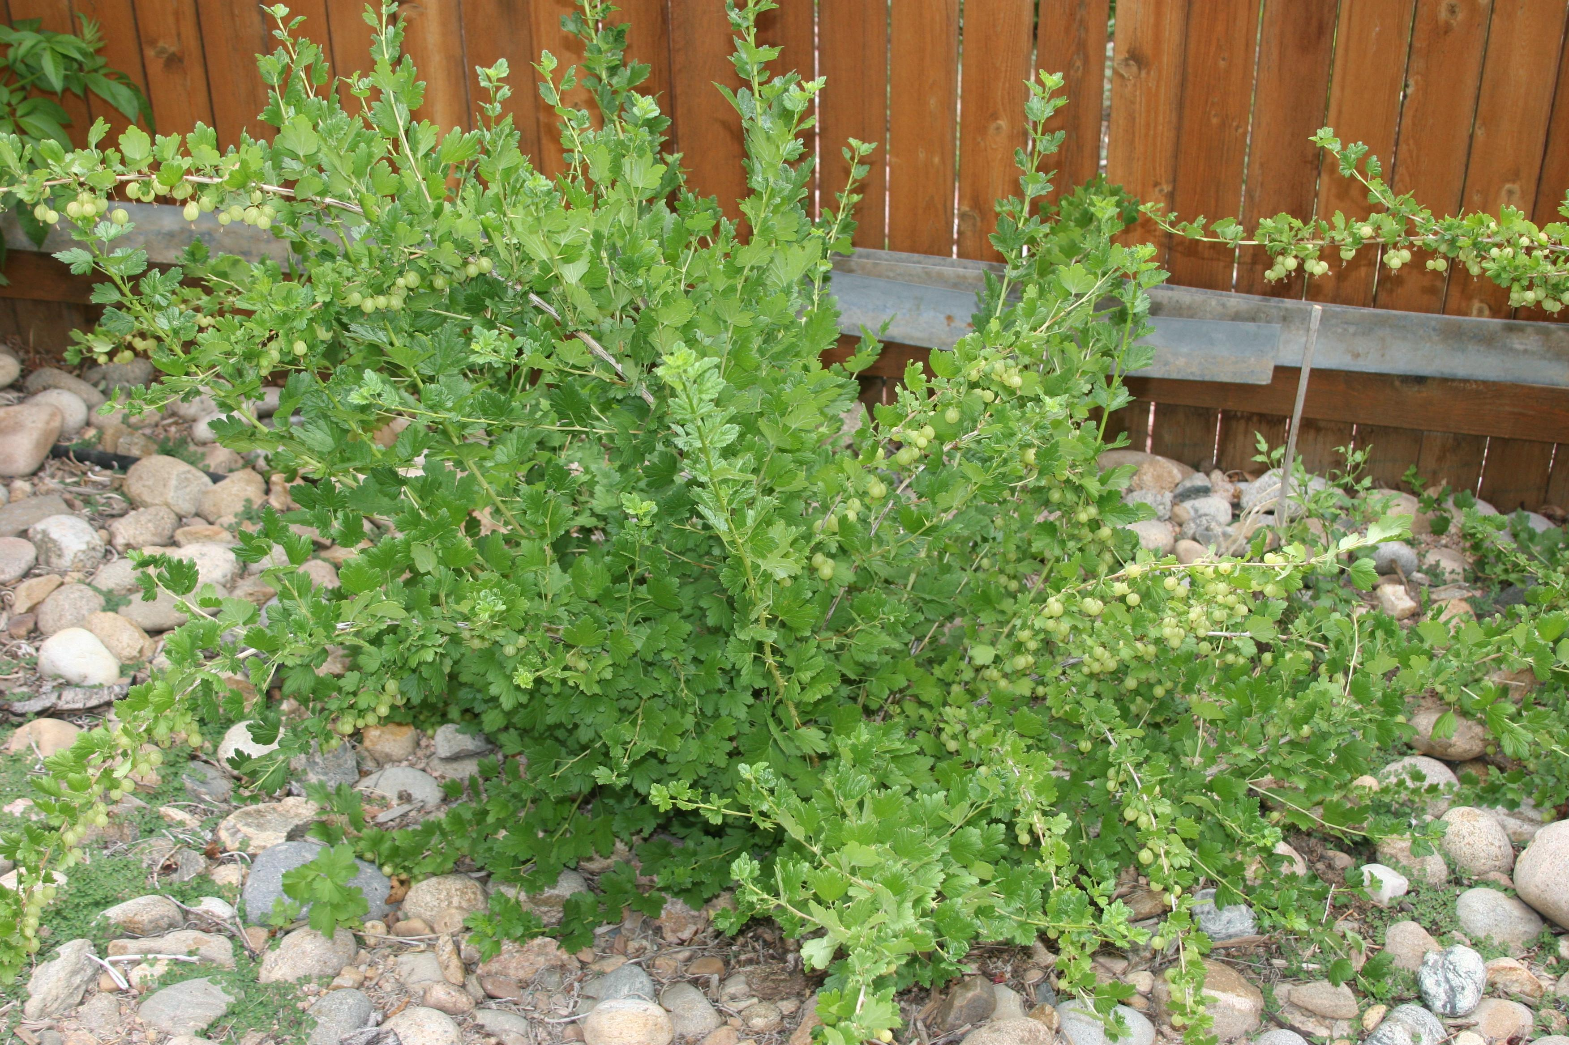
Height: 2.5’
Width: 5’
Blooms: Red oval-shaped berries midsummer
Sun: Full sun to partial shade
Water: Moderate
Hardiness: USDA zones 3-9
Culture: Sandy or clay loam soil
Introduced: 2001
Shrub
Bright green leaves set off many clusters of sweet, huge, red berries in midsummer. Mounding plant with long thorns; good as a hedge. This is the original selection from England, not the selection from Canada. Powdery mildew resistant. Very hardy.

Comanche Gooseberry
Ribes uva-crispa ‘Red Jacket’
www.plantselect.org

