

**Comanche Gooseberry**

*Ribes uva-crispa* ‘Red Jacket’

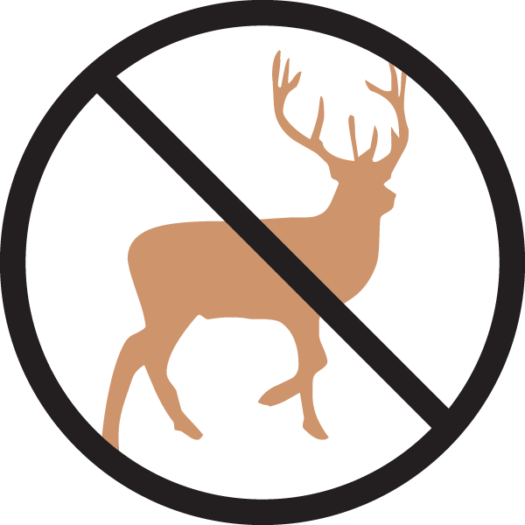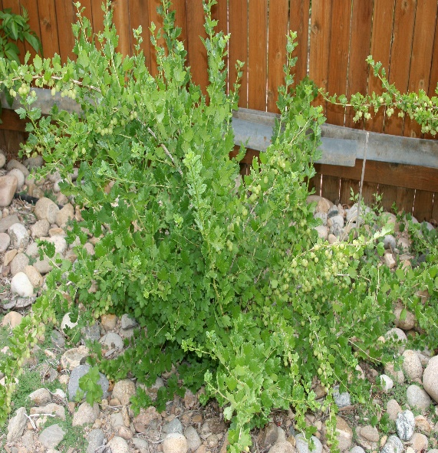

**Height: 2.5 ft. Width: 5 ft.**

Bright green leaves set off many clusters of sweet, huge, red berries in midsummer. Mounding plant with long thorns; good as a hedge. This is the original selection from England, not the selection from Canada. Powdery mildew resistant. Very hardy.

**Culture:** Clay, loam or sandy soil

**Hardiness:** USDA zones 3-9



WIND. HAIL. SNOW. SUN

**BRING IT ON**

www.plantselect.org

