
Autumn Amber Sumac
Rhus trilobata ‘Autumn Amber’


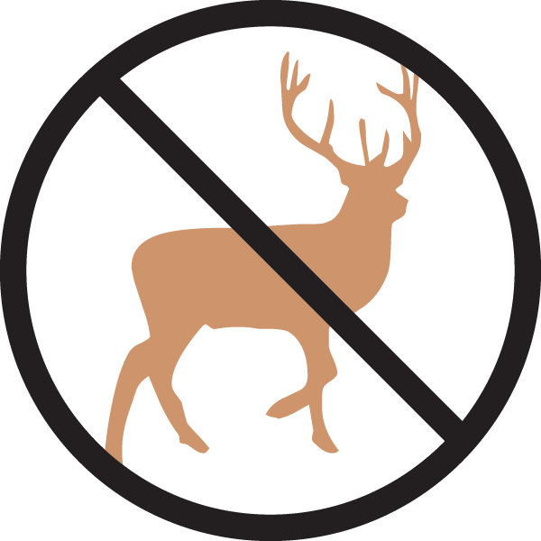




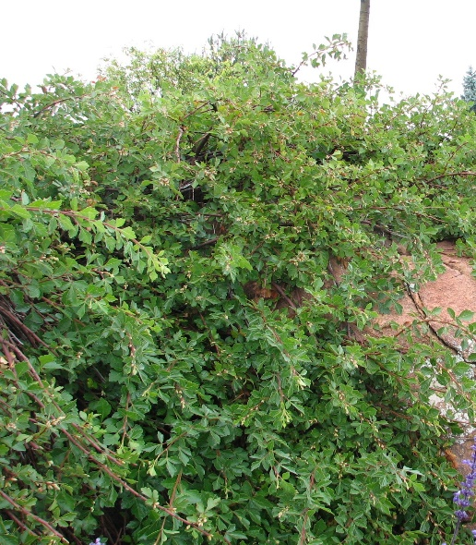
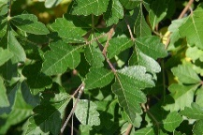

Height: 10-14 in. Width: 6-8 ft.
An ideal ground cover shrub for terraced walls, large open areas and dry shrub areas. Graceful and delicate-looking, yet tough enough to be used in harsh planting sites. Summer leaves glossy, bright green; fall color is amber to reddish.
Culture: Loam or sandy soil
Hardiness: USDA zones 4-8



WIND. HAIL. SNOW. SUN
BRING IT ON

www.plantselect.org



