

**Autumn Amber Sumac**

*Rhus trilobata* ‘Autumn Amber’

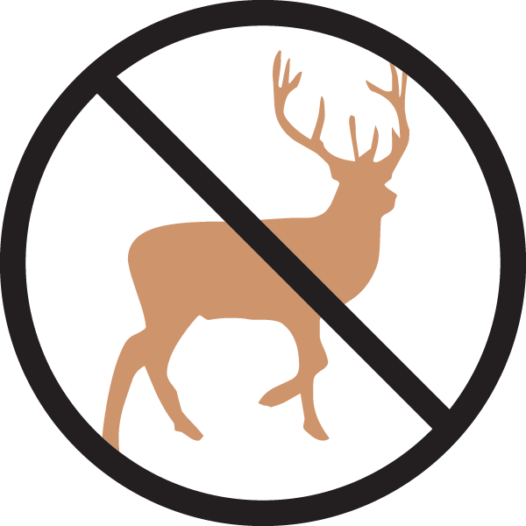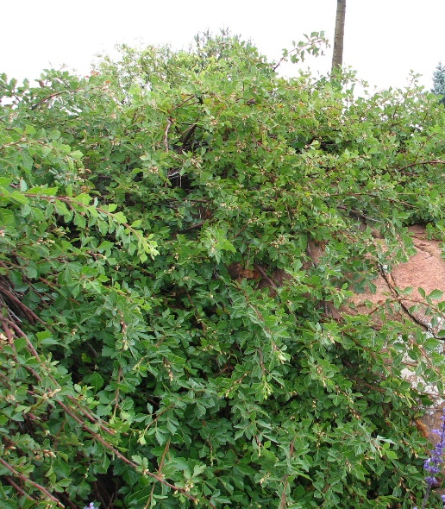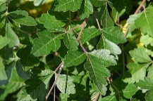

**Height: 10-14 in. Width: 6-8 ft.**

An ideal ground cover shrub for terraced walls, large open areas and dry shrub areas. Graceful and delicate-looking, yet tough enough to be used in harsh planting sites. Summer leaves glossy, bright green; fall color is amber to reddish.

**Culture:** Loam or sandy soil

**Hardiness:** USDA zones 4-8



WIND. HAIL. SNOW. SUN

**BRING IT ON**

www.plantselect.org

