
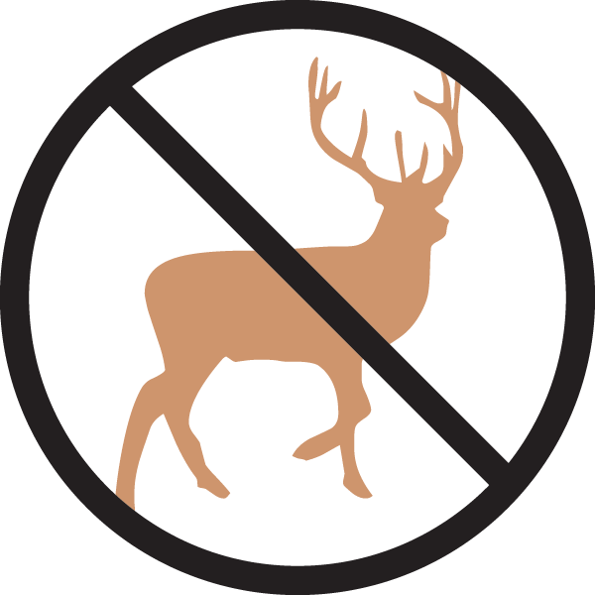


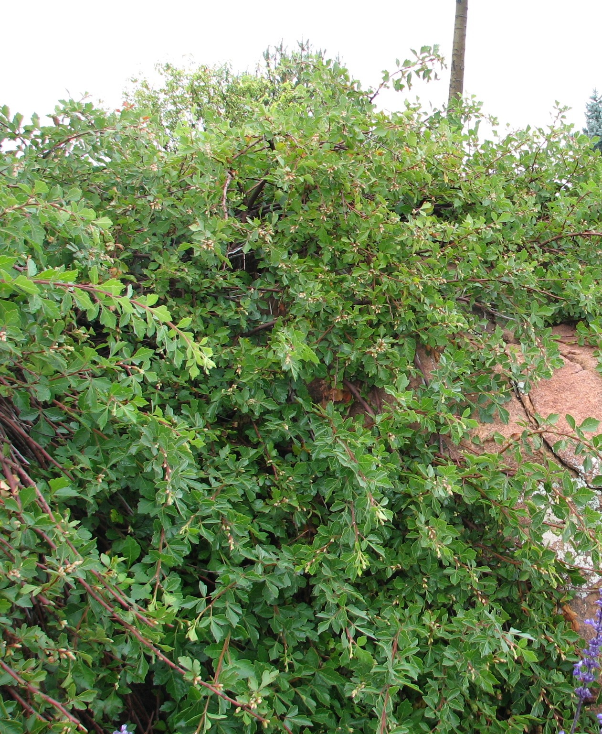
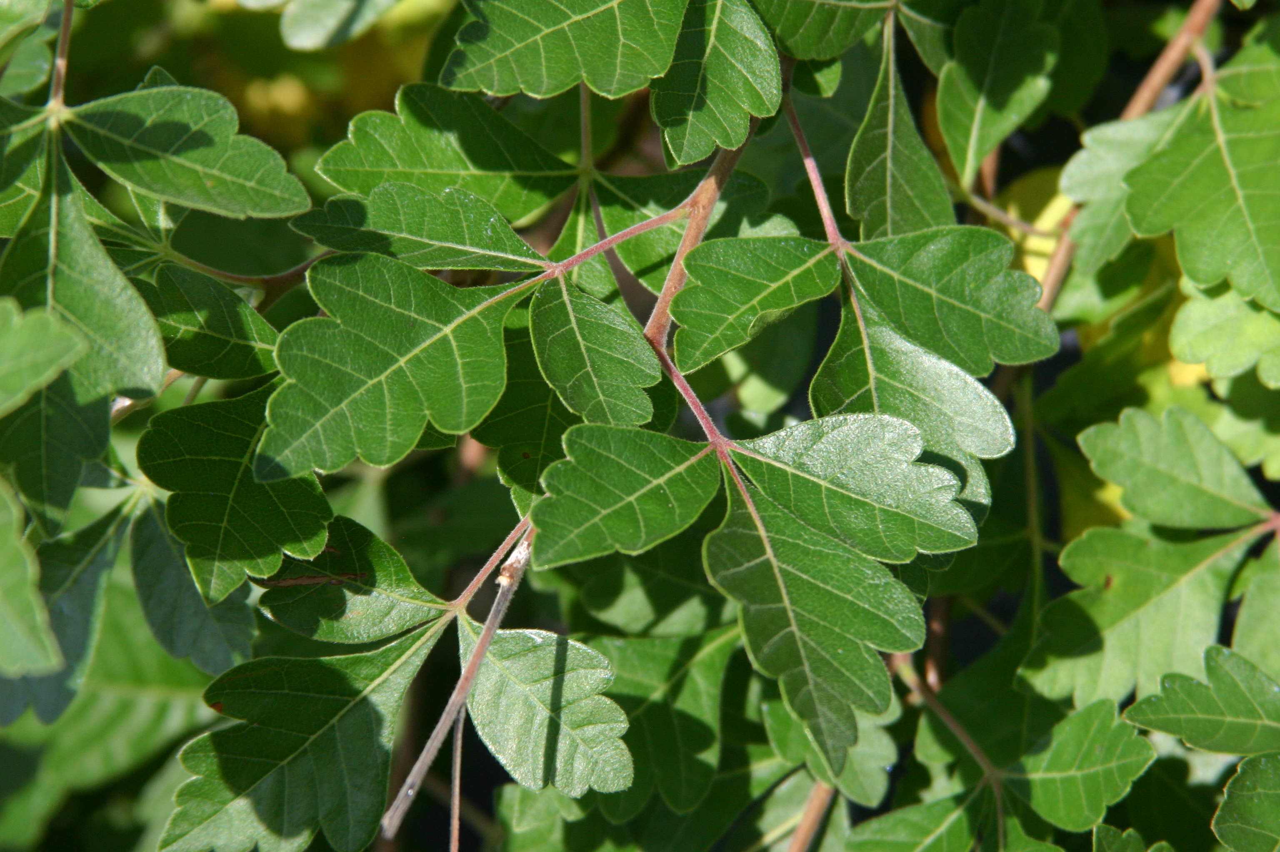
Height: 6-18”
Width: 6-8”
Blooms: Insignificant
Sun: Full sun
Water: Xeric
Hardiness: USDA zones 4-8
Culture: Loam or sandy soils
Recommended: 2014
Groundcover Shrub
An ideal ground cover shrub for terraced walls, large open areas and dry shrub areas. Graceful and delicate-looking, yet tough enough to be used in harsh planting sites. Low-growing selection of native three-leaf sumac developed at the Los Lunas USDA-NRCS center, New Mexico. Summer leaves glossy, bright green; fall color is amber to reddish.

Autumn Amber Sumac
Rhus trilobata ‘Autumn Amber’
www.plantselect.org

