



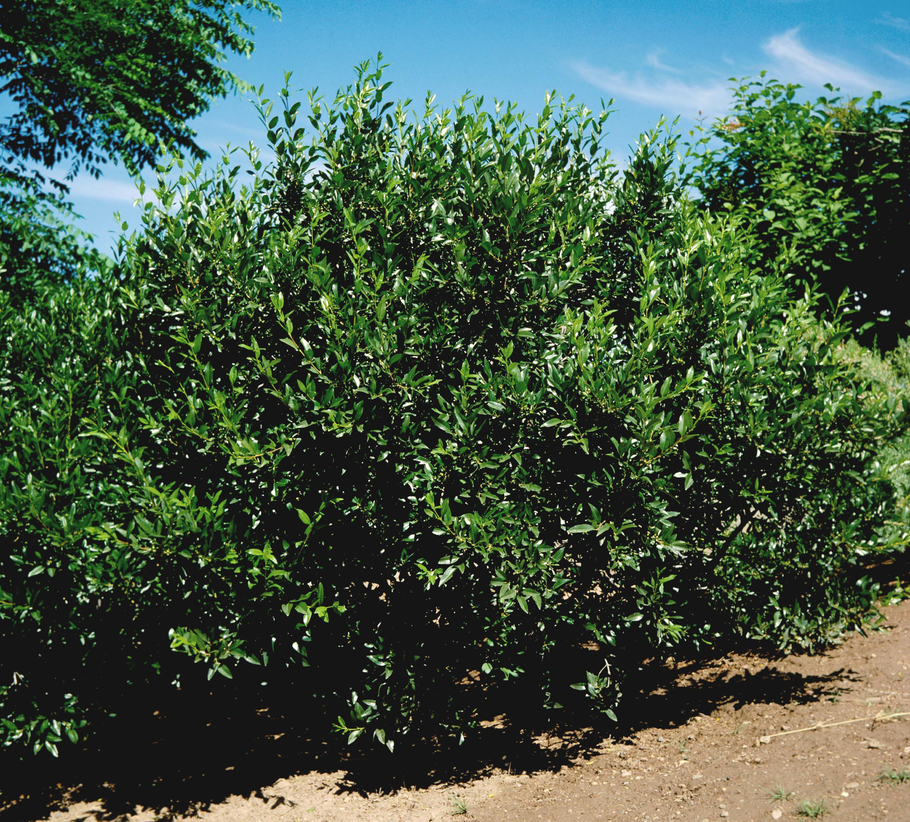
Height: 8-10’
Width: 8-10’
Blooms: Inconspicuous in spring
Sun: Full sun to partial shade
Water: Moderate to dry
Hardiness: USDA zones 4-8
Culture: Sandy soil or clay loam
Introduced: 2002
Shrub
A Southwestern native shrub that has a lovely form, with sturdy, thornless branches and dark green foliage. This plant has been grown at the Upper Colorado Plant Environment Center at Meeker, Colorado, for nearly twenty years. Birds are attracted to the black fruit during the summer.

Smith Buckthorn
Rhamnus smithii
www.plantselect.org

