

**Smith Buckthorn**

*Rhamnus smithii*

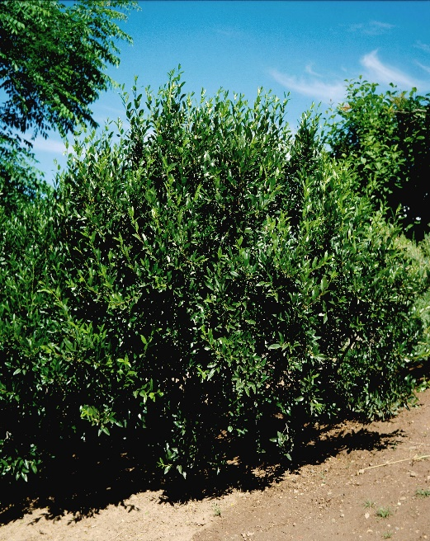

**Height: 8-10 ft. Width: 8-10 ft.**

A Southwestern native shrub that has a lovely form, with sturdy, thornless branches and dark green foliage. This plant has been grown at the Upper Colorado Plant Environment Center at Meeker, Colorado, for nearly twenty years. Birds are attracted to the black fruit during the summer.

**Culture:** Sandy soil or clay loam

**Hardiness:** USDA zones 4-8



WIND. HAIL. SNOW. SUN

**BRING IT ON**

www.plantselect.org

