


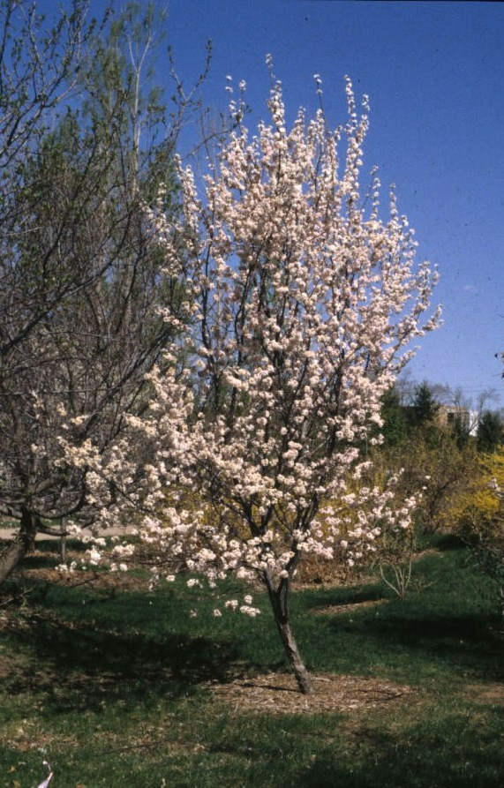
Height: 15-20’
Width: 15’
Blooms: Early spring
Sun: Full sun to partial shade
Water: Moderate
Hardiness: USDA zones 4b-9
Culture: Average soil
Introduced: 2000
Tree
Fast growing small to medium-sized flowering tree forms a neat, oval-shaped crown with attractive foliage, bright white, double blossoms and smooth, dark brown bark. Spectacular red fall color and winter form round out the four season appeal of this underutilized selection.

Princess Kay Plum
Prunus nigra ‘Princess Kay’
www.plantselect.org

