

**Princess Kay Plum**

*Prunus nigra* ‘Princess Kay’

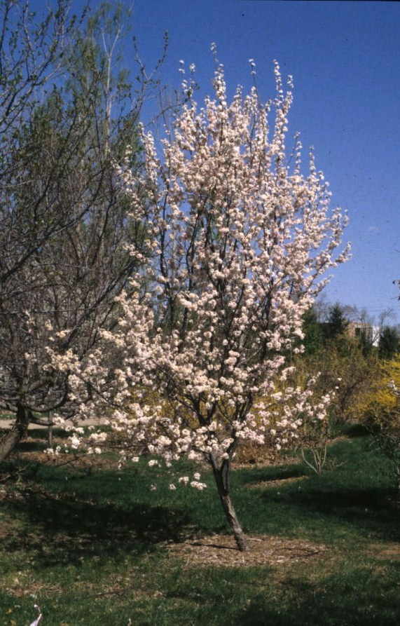

**Height: 15-20 ft. Width: 15-20 ft.**

Fast growing small to medium-sized flowering tree forms a neat, oval-shaped crown with attractive foliage, bright white, double blossoms and smooth, dark brown bark. Spectacular red fall color and winter form round out the four season appeal of this underutilized selection.

**Culture:** Loam soil

**Hardiness:** USDA zones 4b-9



WIND. HAIL. SNOW. SUN

**BRING IT ON**

www.plantselect.org

