

**Pawnee Buttes® Sand Cherry**

*Prunus besseyi* ‘P011S’

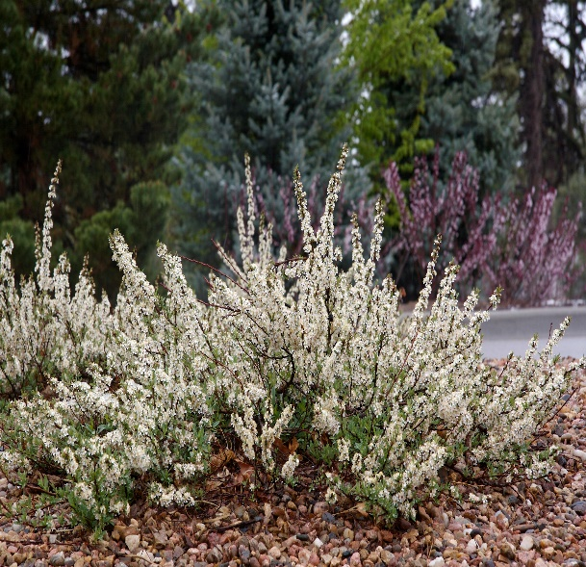

**Height: 15-18 in. Width: 4-6 ft.**

A graceful, ground covering form of our native sand cherry. Lustrous, green leaves turn bright red and purple in fall. Fragrant, white flowers in April produce heavy crops of black cherries in summer that are attractive to wildlife.

**Culture:** Clay, loam or sandy soil

**Hardiness:** USDA zones 3-8



WIND. HAIL. SNOW. SUN

**BRING IT ON**

www.plantselect.org

