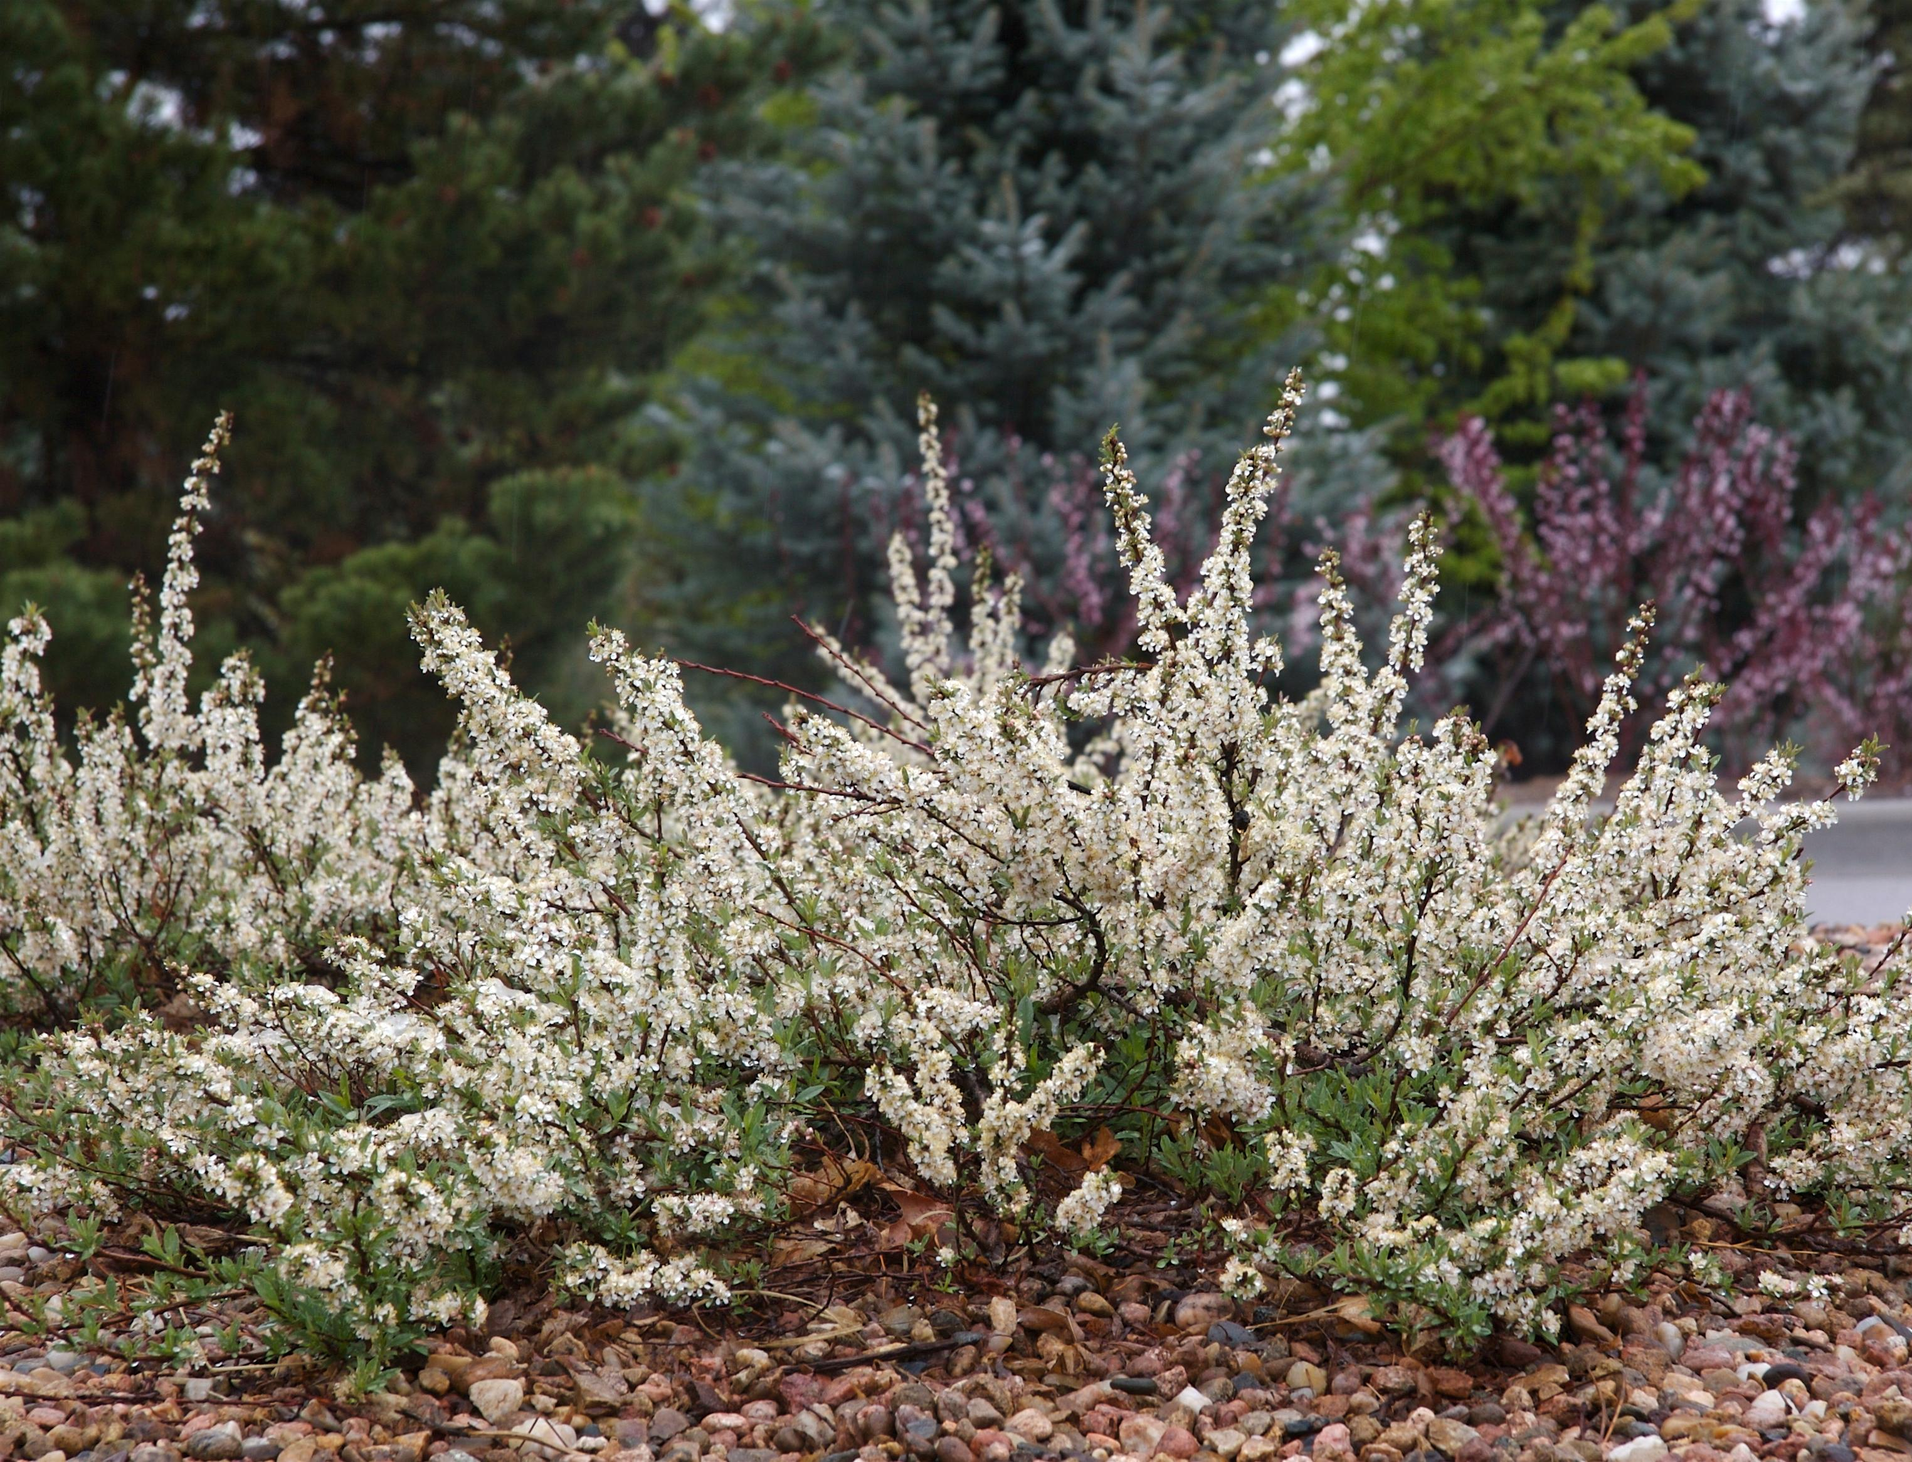



Height: 15-18”
Width: 4-6’
Blooms: Early spring
Sun: Full sun to partial shade
Water: Moderate to dry
Hardiness: USDA zones 3-8
Culture: Average soil
Introduced: 2000
Shrub
A graceful, ground covering form of our native sand cherry. Lustrous, green leaves turn bright red and purple in fall. Fragrant, white flowers in April produce heavy crops of black cherries in summer that are attractive to wildlife.

Pawnee Buttes® Sand Cherry
Prunus besseyi
www.plantselect.org

