

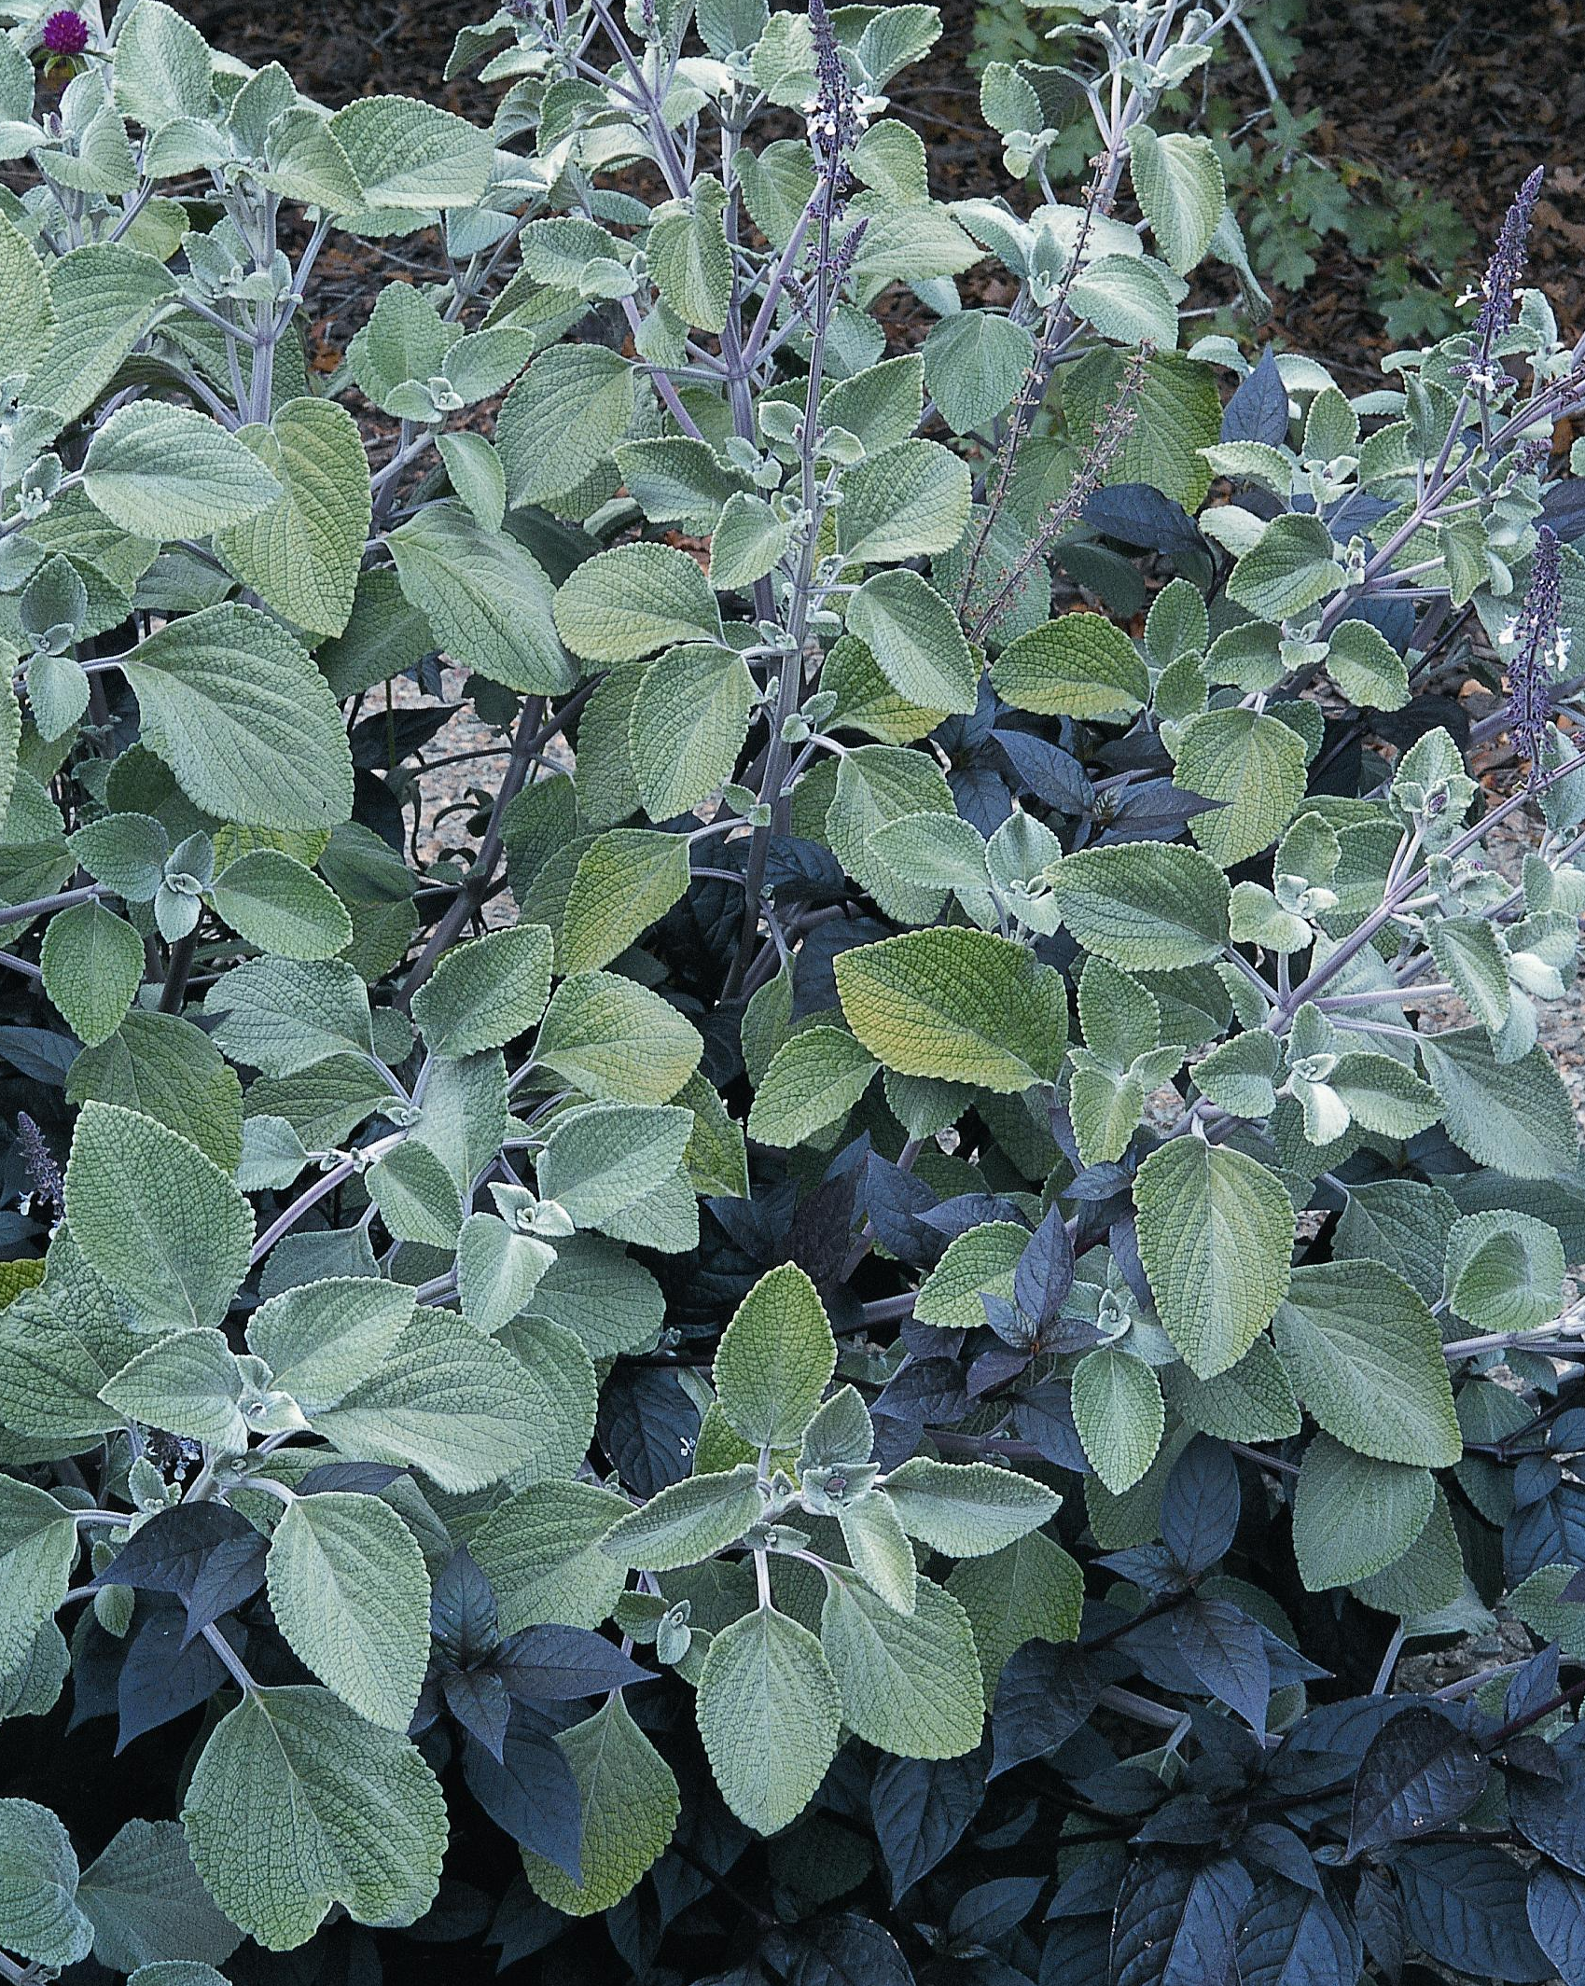
Height: 20-36”
Width: 20-40”
Sun: Full sun to partial shade
Water: Moderate
Hardiness: Annual in climates with frost
Culture: Average soil
Introduced: 1999
Annual
Plush silver heavily textured leaves make a trim mound through the summer months. Very easy and adaptable in a variety of sites and soils. A great filler plant in the border.

Silver Dollar Plant
Plectranthus argentatus
www.plantselect.org

