
Silver Dollar Plant
Plectranthus argentatus

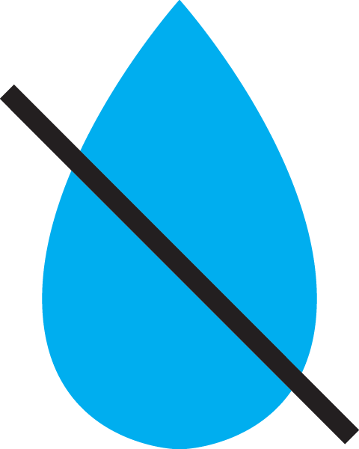



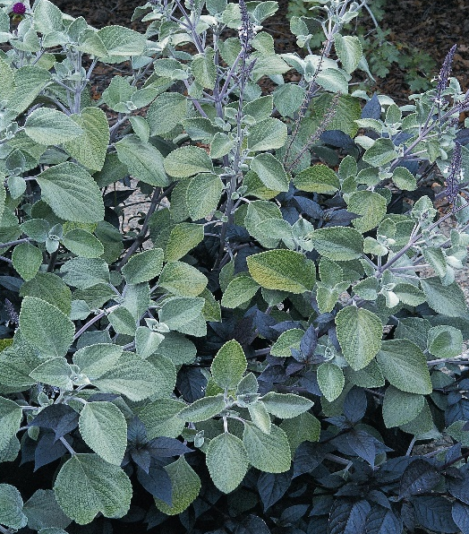

Height: 28-32 in. Width: 28-32 in.
Plush silver heavily textured leaves make a trim mound through the summer months. Very easy and adaptable in a variety of sites and soils. A great filler plant in the border.
Culture: Loam
Hardiness: Annual in climates with frost



WIND. HAIL. SNOW. SUN
BRING IT ON

www.plantselect.org



