

**Silver Dollar Plant**

*Plectranthus argentatus*

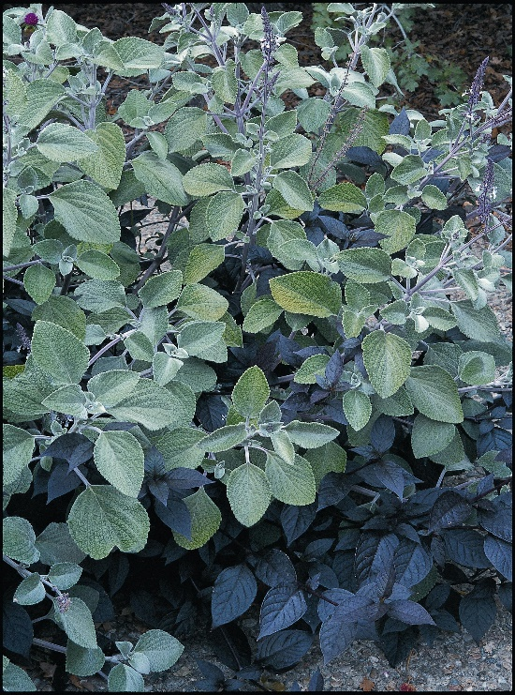

**Height: 20-36 in. Width: 20-40 in.**

Plush silver heavily textured leaves make a trim mound through the summer months. Very easy and adaptable in a variety of sites and soils. A great filler plant in the border.

**Culture:** Average soil

**Hardiness:** USDA zones 4-10



WIND. HAIL. SNOW. SUN

**BRING IT ON**

www.plantselect.org

