





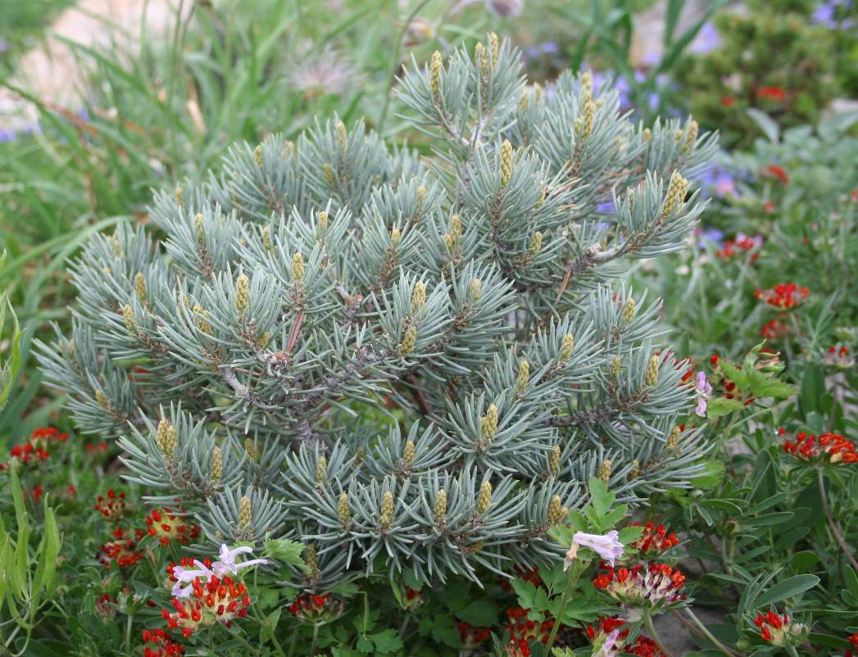
Height: 24 in. (1-3 in per year)
Width: 24 in.
Hardiness: USDA zones 4-7
Culture: Well-drained, sandy
Slow growing, adaptable and durable, Blue Jazz is the most ornamental of the dwarf pinion pines now available. This globe-forming little pine is the perfect addition to any water-wise garden that needs a permanent small evergreen presence.
Blue Jazz pinion pine
Pinus monophylla ‘Blue Jazz’
www.plantselect.org

