

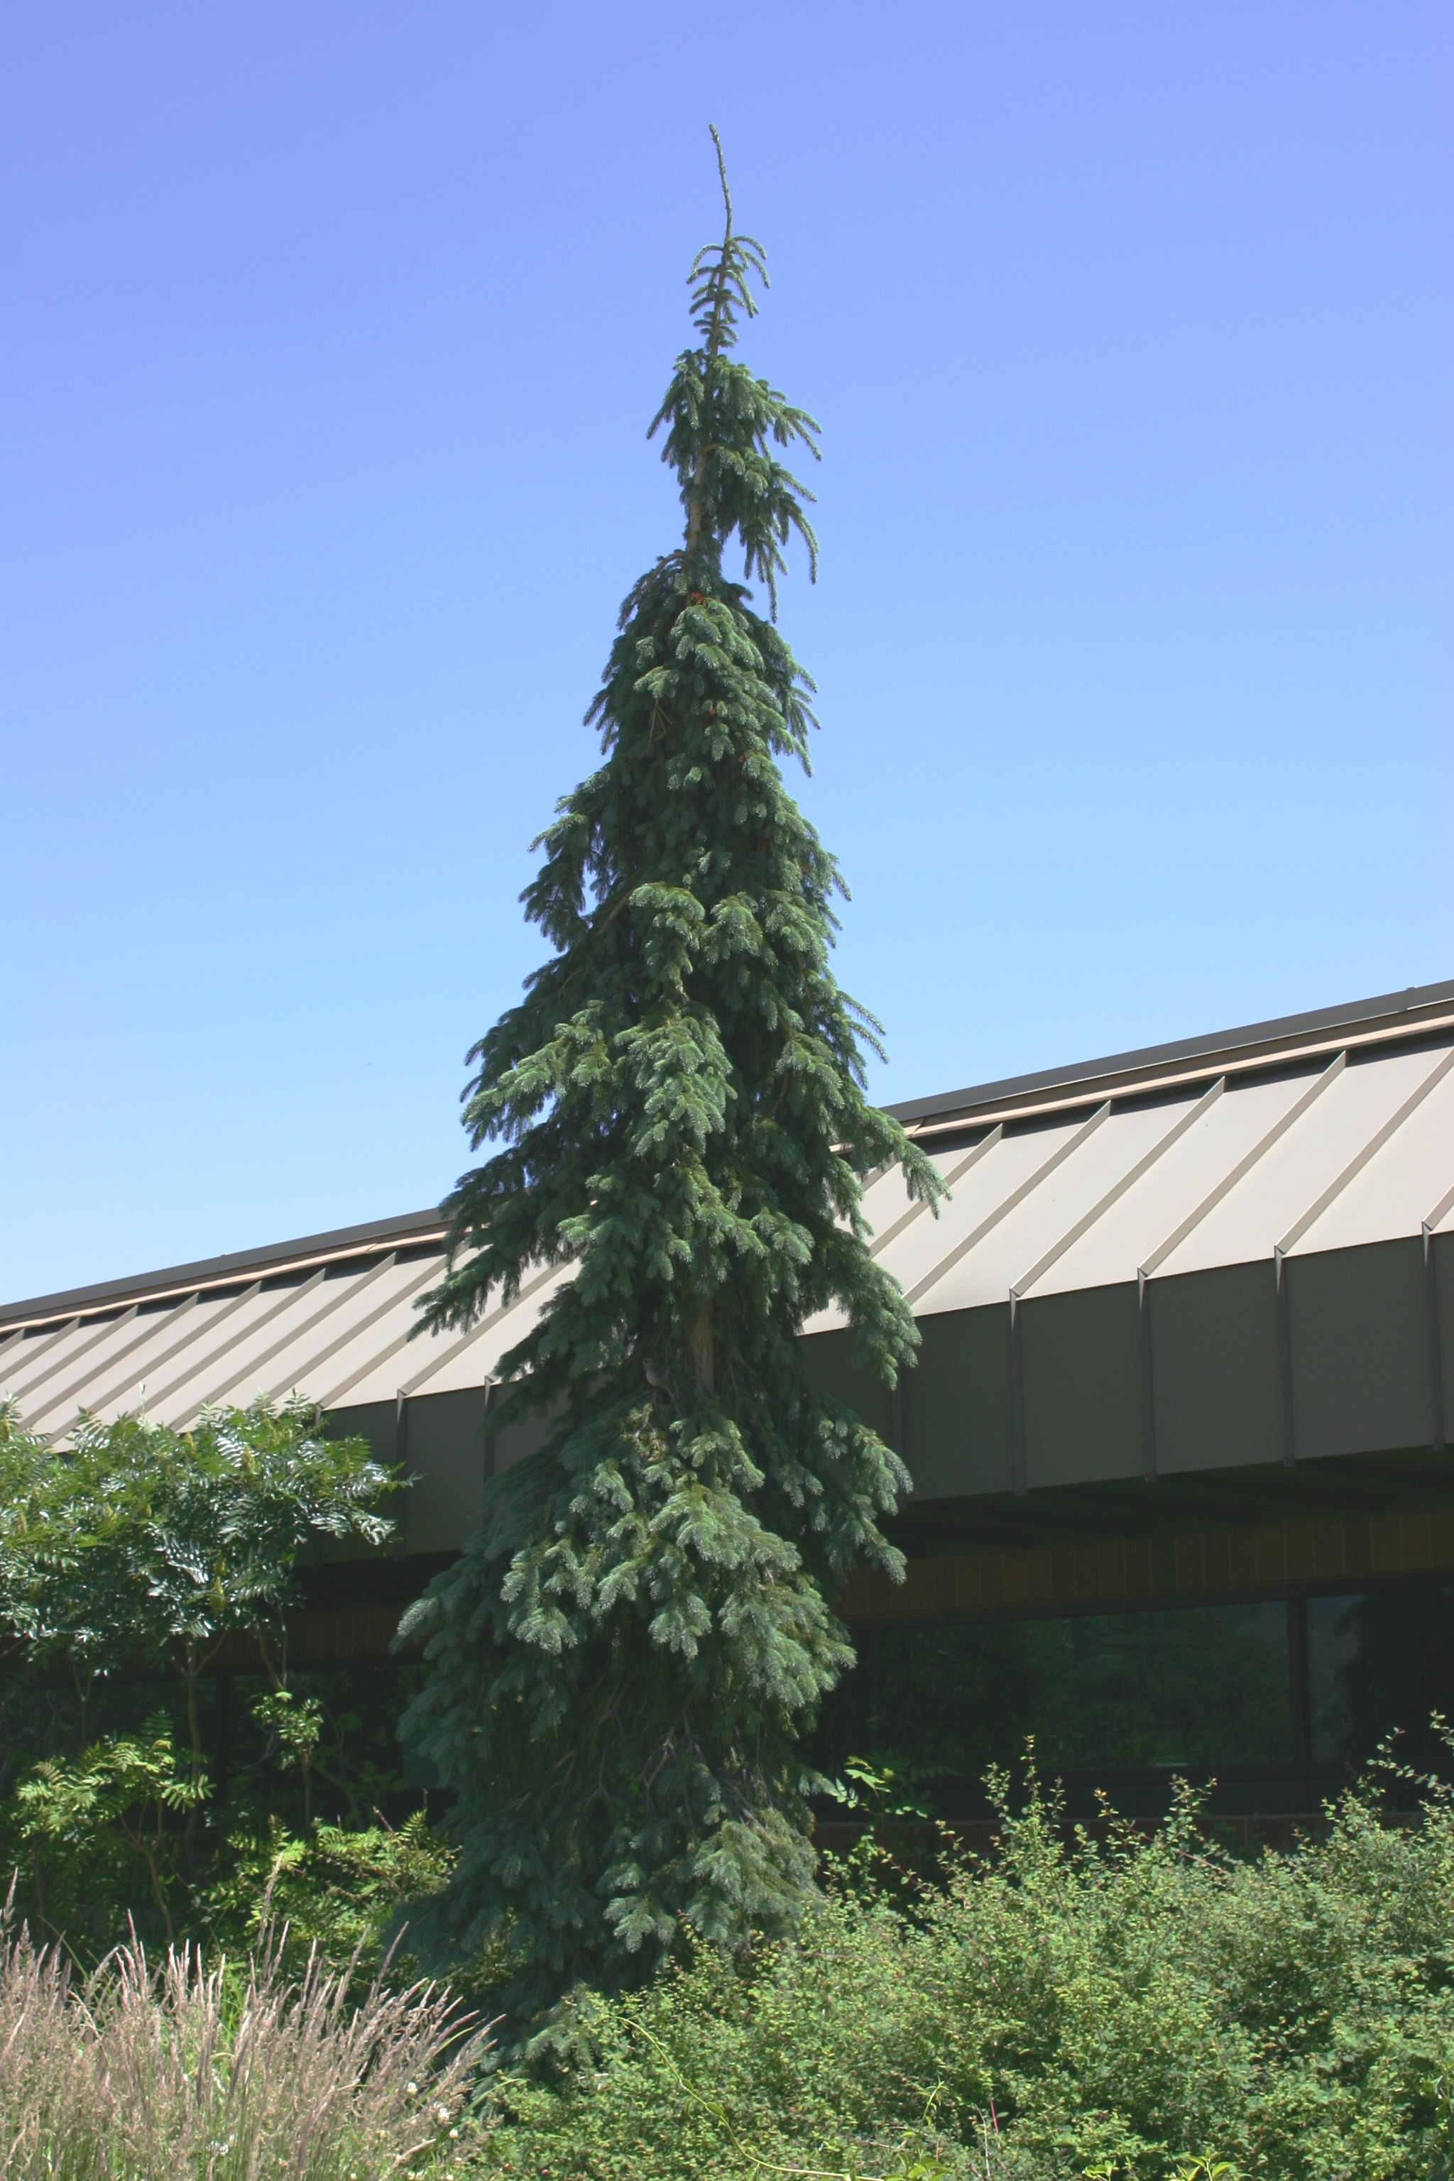
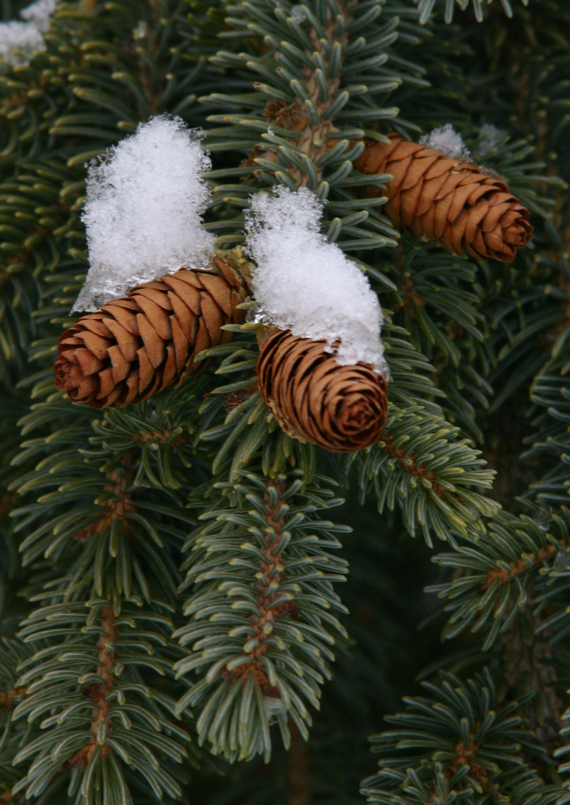
Height: 20-30’
Width: 6’
Sun: Full sun to partial shade
Water: Moderate to dry
Hardiness: USDA zones 3-8 (up to 10,000’)
Culture: Loam or sandy soils
Introduced: 2012
Evergreen Conifer
This first PLANT SELECT® conifer recommendation is a living sculpture for the landscape. Very hardy form of the boreal spruce that also thrives in summer heat. The graceful foliage shimmers, and the weeping form adds drama and texture to any setting. With its compact footprint, this distinctive specimen enhances tight landscape and garden settings. A must-have for winter interest!

Weeping White Spruce
Picea glauca ‘Pendula’
www.plantselect.org

