

**Weeping White Spruce**

*Picea glauca* ‘Pendula’

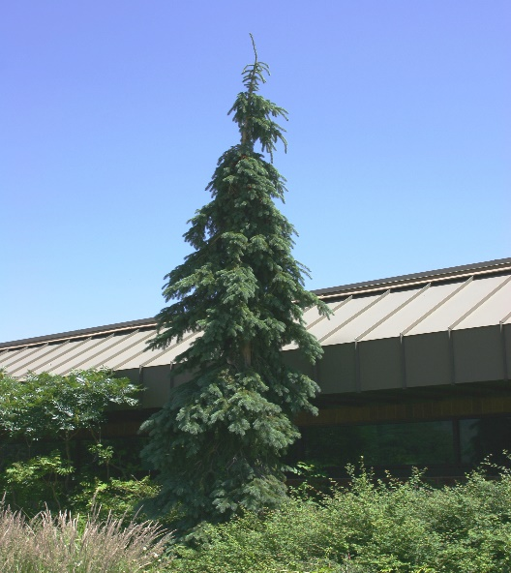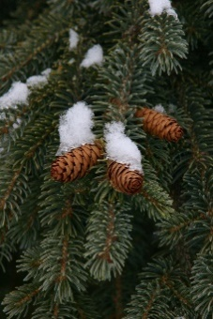

**Height: 20-24 ft. Width: 4-6 ft.**

Very hardy form of the boreal spruce that also thrives in summer heat. The graceful foliage shimmers, and the weeping form adds drama and texture to any setting. With its compact footprint, this distinctive specimen enhances tight landscape and garden settings.

**Culture:** Loam or sandy soil

**Hardiness:** USDA zones 3-8



WIND. HAIL. SNOW. SUN

**BRING IT ON**

www.plantselect.org

