

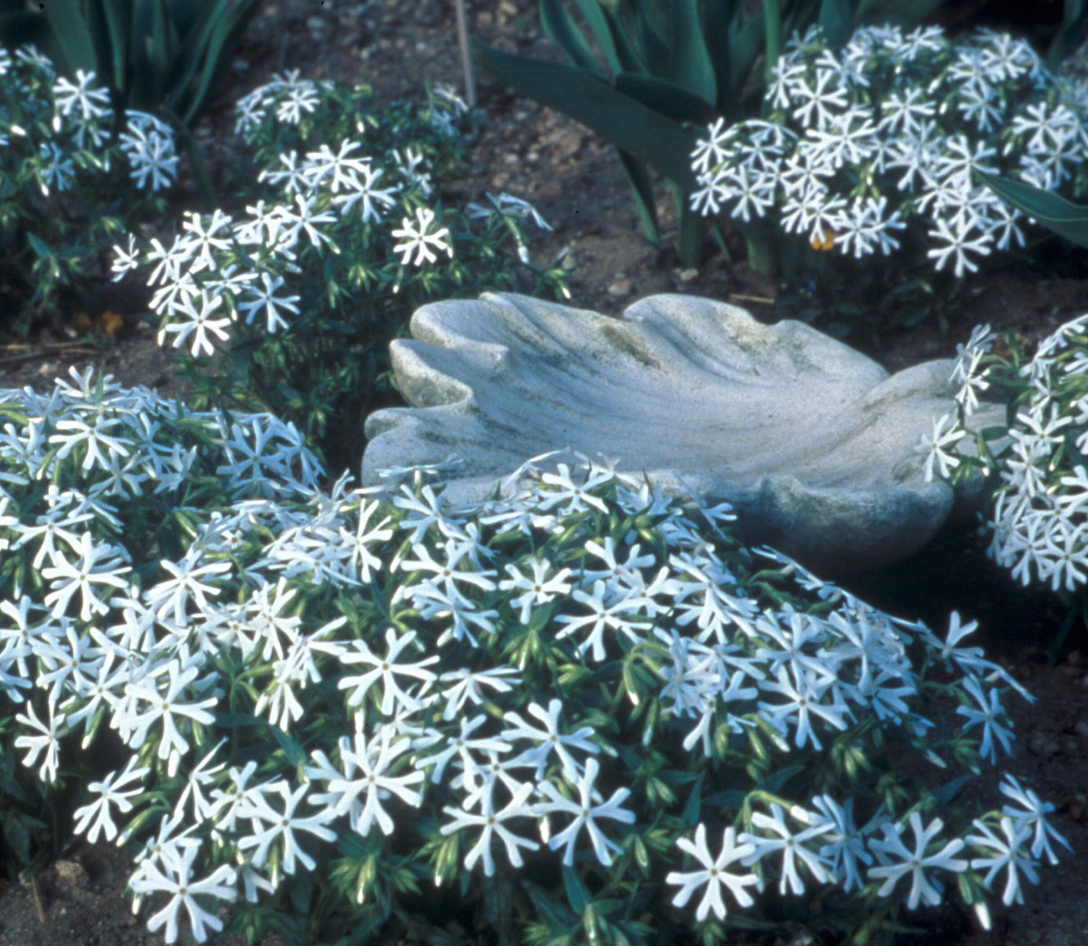
Height: 4-8”
Width: 18-24”
Blooms: April to June
Sun: Full sun to partial shade
Water: Moderate
Hardiness: USDA zones 4b-9 (up to 7,000’)
Culture: Average, clay, or sandy soil
Introduced: 2006
Perennial
Dark evergreen mats of 2” leaves completely covered with a drift of white snowflake-like flowers in spring.

Snowmass® Phlox
Phlox bifida
www.plantselect.org

