
Snowmass® Phlox
Phlox bifida

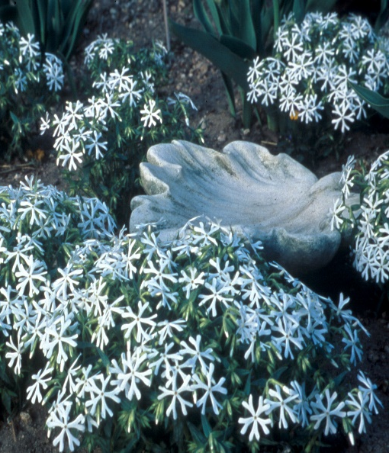




Height: 4-8 in. Width: 14-18 in.
Dark evergreen mats of 2” leaves completely covered with a drift of white snowflake-like flowers April to June.
Culture: Clay, loam or sandy soil
Hardiness: USDA zones 4b-9



WIND. HAIL. SNOW. SUN
BRING IT ON

www.plantselect.org



