

**Snowmass® Phlox**

*Phlox bifida*

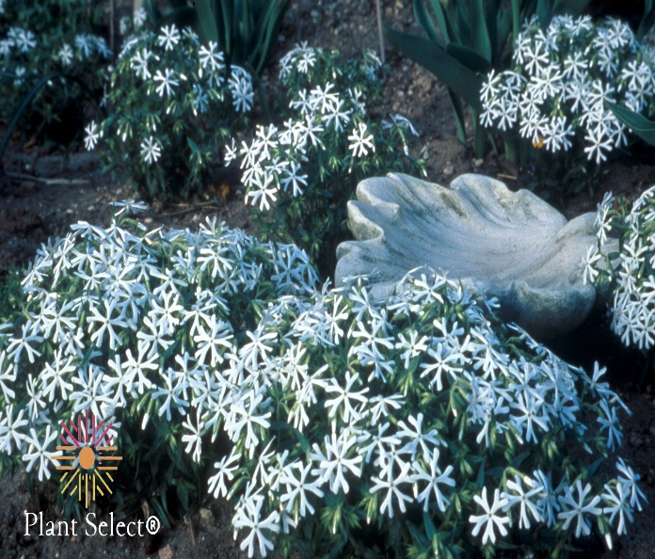

**Height: 4-8 in. Width: 14-18 in.**

Dark evergreen mats of 2” leaves completely covered with a drift of white snowflake-like flowers April to June.

**Culture:** Clay, loam or sandy soil

**Hardiness:** USDA zones 4b-9



WIND. HAIL. SNOW. SUN

**BRING IT ON**

www.plantselect.org

