


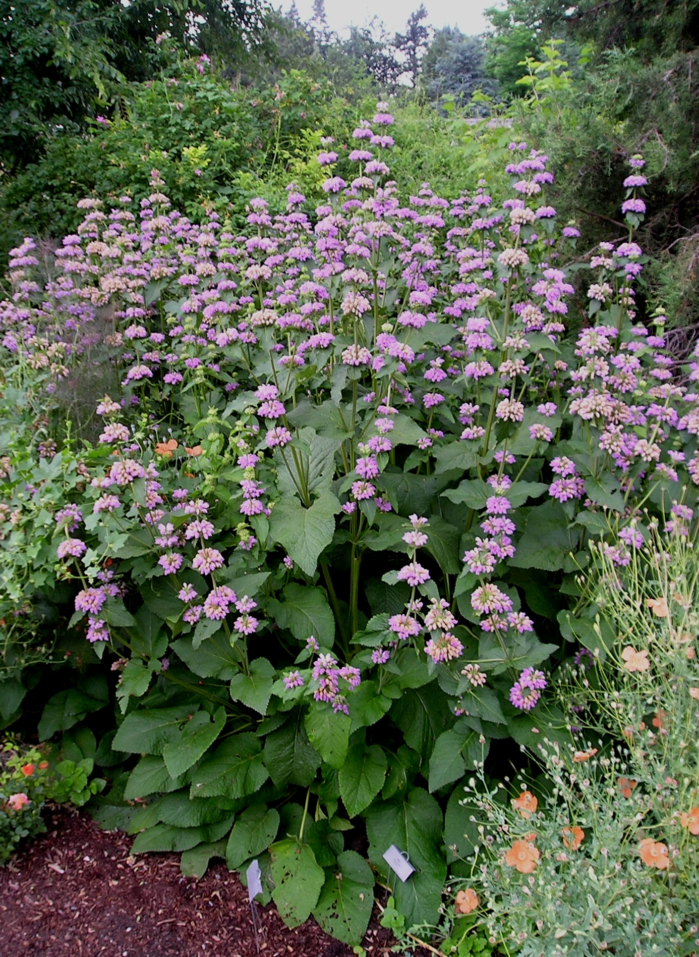
Height: 36-60”
Width: 18-30”
Blooms: Early summer
Sun: Full sun to shade
Water: Moderate in sun to dry in shade
Hardiness: USDA zones 4b-8
Culture: Average, clay, or sandy soil
Introduced: 2004
Perennial
Stately herb with large, textured foliage and whorls of showy flowers. Cool, lavender-pink flowers can be cut for fresh or dry arrangements. Upright architectural form and whorled seed heads are highly ornamental in fall and winter.

Cashmere Sage
Phlomis cashmeriana
www.plantselect.org

