
Cashmere Sage
Phlomis cashmeriana




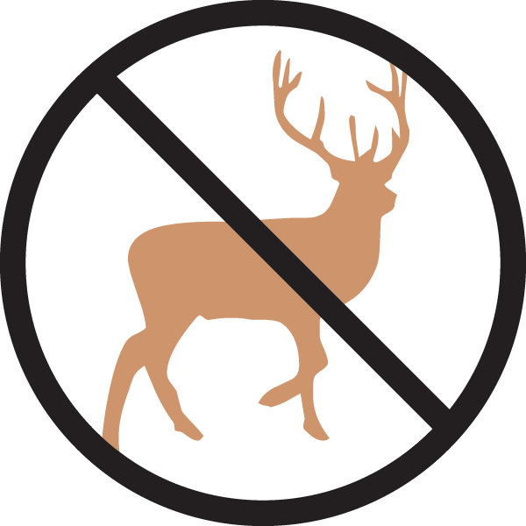


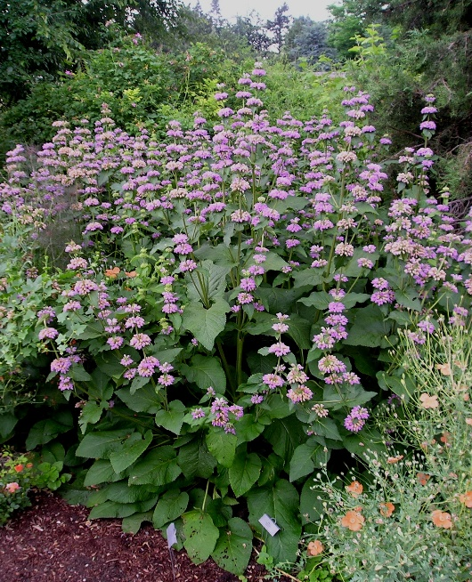

Height: 36-60 in. Width: 18-30 in.
Stately herb with large, textured foliage and whorls of showy lavender-pink flowers in early summer. Upright architectural form and whorled seed heads are highly ornamental in fall and winter. Suitable for dry, light shade. Useful in cut flower arrangements.
Culture: Clay, loam or sandy soil
Hardiness: USDA zones 4b-8



WIND. HAIL. SNOW. SUN
BRING IT ON

www.plantselect.org



