

**Cashmere Sage**

*Phlomis cashmeriana*

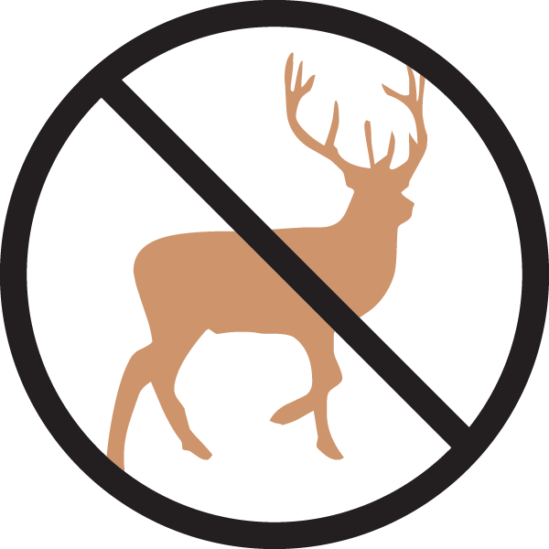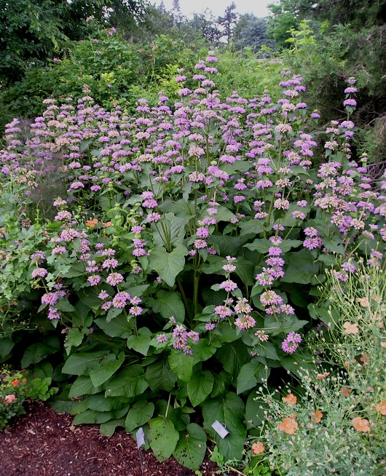

**Height: 36-60 in. Width: 18-30 in.**

Stately herb with large, textured foliage and whorls of showy lavender-pink flowers in early summer. Upright architectural form and whorled seed heads are highly ornamental in fall and winter. Suitable for dry, light shade. Useful in cut flower arrangements.

**Culture:** Clay, loam or sandy soil

**Hardiness:** USDA zones 4b-8



WIND. HAIL. SNOW. SUN

**BRING IT ON**

www.plantselect.org

