


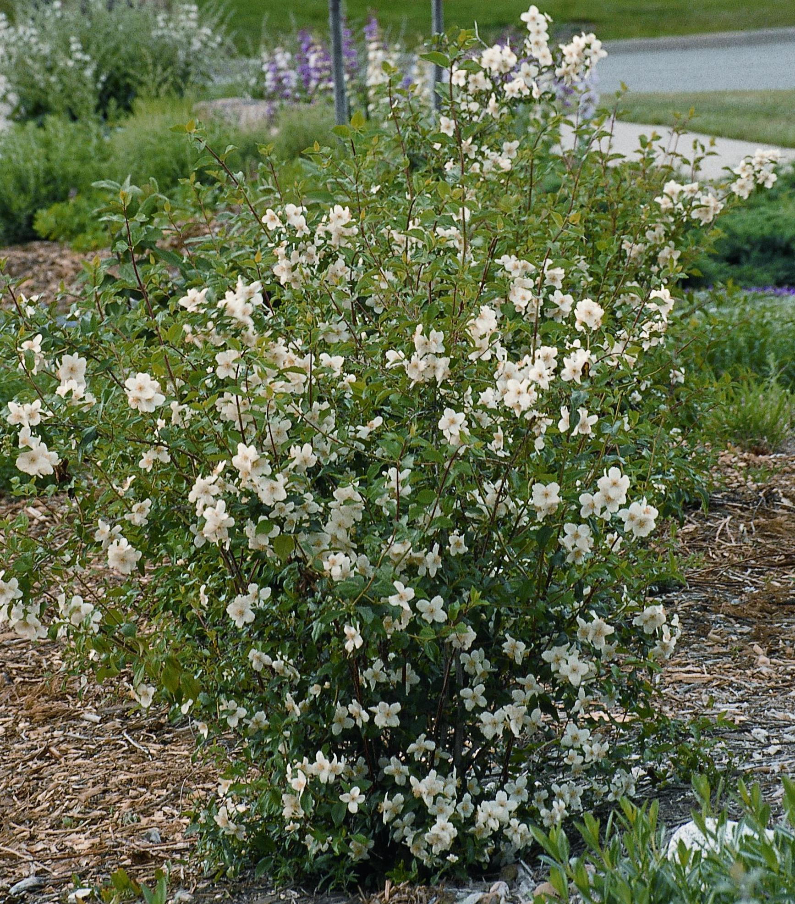
Height: 7’
Width: 6’
Blooms: Early summer
Sun: Full sun to partial shade
Water: Moderate to dry
Hardiness: USDA zones 3-9
Culture: Average soil
Introduced: 2001
Shrub
This North American native forms an attractive shape in a variety of sites and soils. A selection at the USDA Field Station at Cheyenne, Wyoming, where the parent plant has formed a spectacular and carefree specimen. It has thrived over many decades with no care. Intensely fragrant, nearly two-inch, white blooms.

Cheyenne Mock Orange
Philadelphus lewisii
www.plantselect.org

