

**Cheyenne Mock Orange**

*Philadelphus lewisii* ‘PWY01S’

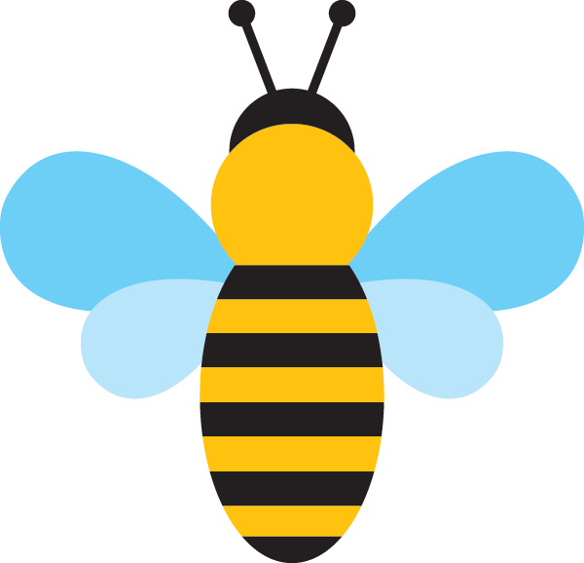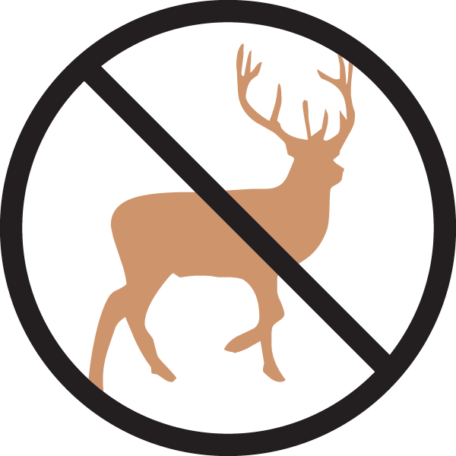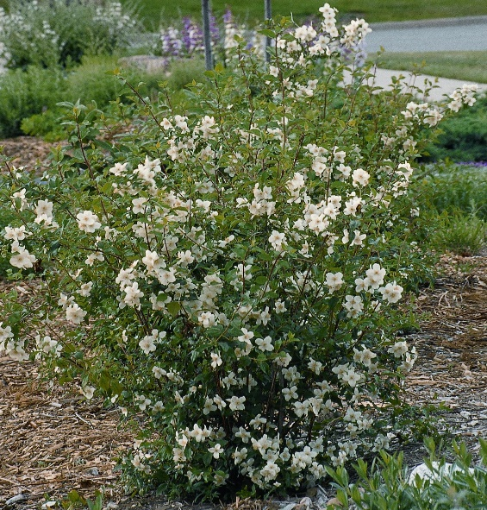

**Height: 6-7 ft. Width: 6-7 ft.**

A selection at the USDA Field Station at Cheyenne, Wyoming, where the parent plant has formed a spectacular and carefree specimen. It has thrived over many decades with no care. Intensely fragrant, nearly two-inch, white blooms.

**Culture:** Dry clay or sandy loam

**Hardiness:** USDA zones 3-9



WIND. HAIL. SNOW. SUN

**BRING IT ON**

www.plantselect.org

