

**Windwalker® Garnet Penstemon**

*Penstemon x mexicali* ‘PWIN02S’

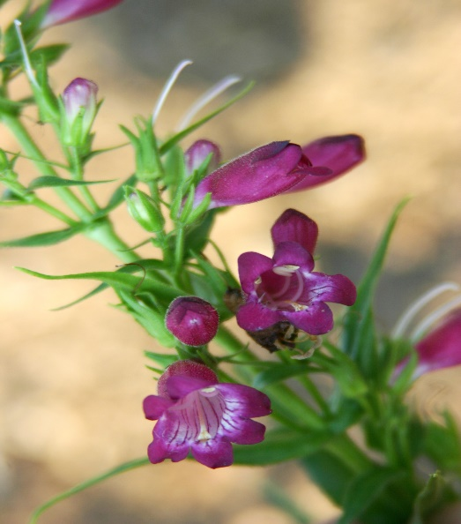

**Height: 14-18 in. Width: 12-14 in.**

Ruby-red or garnet-colored tubular flowers with striped throats nearly all summer long. Narrow, glossy green leaves form an attractive mound. This selection is a hybrid between Mexican and American wild penstemons developed by Kelly Grummons.

**Culture:** Clay, loam or sandy soil

**Hardiness:** USDA zones 4b-8



WIND. HAIL. SNOW. SUN

**BRING IT ON**

www.plantselect.org

