

**Red Rocks® Penstemon**

*Penstemon x mexicali* ‘P008S’

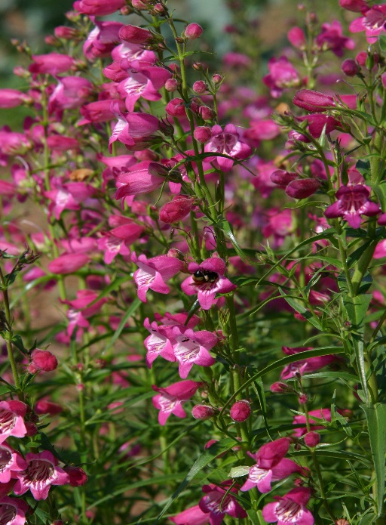

**Height: 14-18 in. Width: 12-14 in.**

Durable hybrid penstemons selected from crosses made by Bruce Meyers between Mexican and American wild penstemons. Narrow, dark green leaves form an attractive mound. Red Rocks® sports a constant succession of bright rose flowers all summer.

**Culture:** Clay, loam or sandy soil

**Hardiness:** USDA zones 4b-8



WIND. HAIL. SNOW. SUN

**BRING IT ON**

www.plantselect.org

