
Shadow Mountain® Penstemon
Penstemon x mexicali ‘Psmyers’







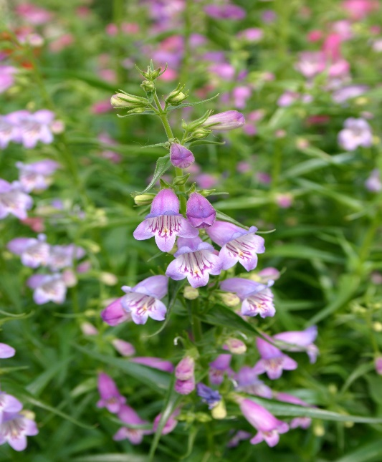

Height: 18-24 in. Width: 14-18 in.
Lavender-blue cousin to Red Rocks® Penstemon blooms from late spring through summer. Very adaptable.
Culture: Clay, loam or sandy soil
Hardiness: USDA zones 4b-8



WIND. HAIL. SNOW. SUN
BRING IT ON

www.plantselect.org



