

**Shadow Mountain® Penstemon**

*Penstemon x mexicali ‘Psmyers’*

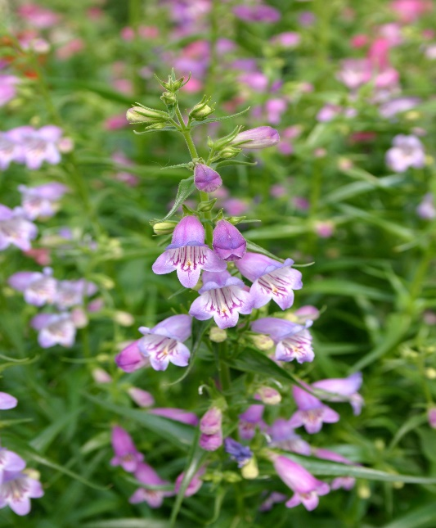

**Height: 18-24 in. Width: 14-18 in.**

Lavender-blue cousin to Red Rocks® Penstemon blooms from late spring through summer. Very adaptable.

**Culture:** Clay, loam or sandy soil

**Hardiness:** USDA zones 4b-8



WIND. HAIL. SNOW. SUN

**BRING IT ON**

www.plantselect.org

