



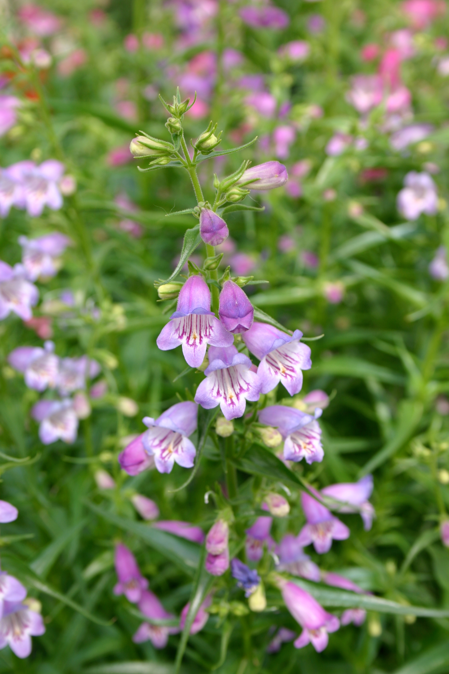
Height: 18-24”
Width: 15-18”
Blooms: May to September
Sun: Full sun to partial shade
Water: Moderate to xeric (once established)
Hardiness: USDA zones 4b-8 (up to 7,000’)
Culture: Clay, loam or sandy soil
Introduced: 2007
Perennial
Lavender-blue cousin to Red Rocks® Penstemon blooms from late spring through summer. Very adaptable.

Shadow Mountain® Penstemon
Penstemon x mexicali ‘Psmyers’
www.plantselect.org

