



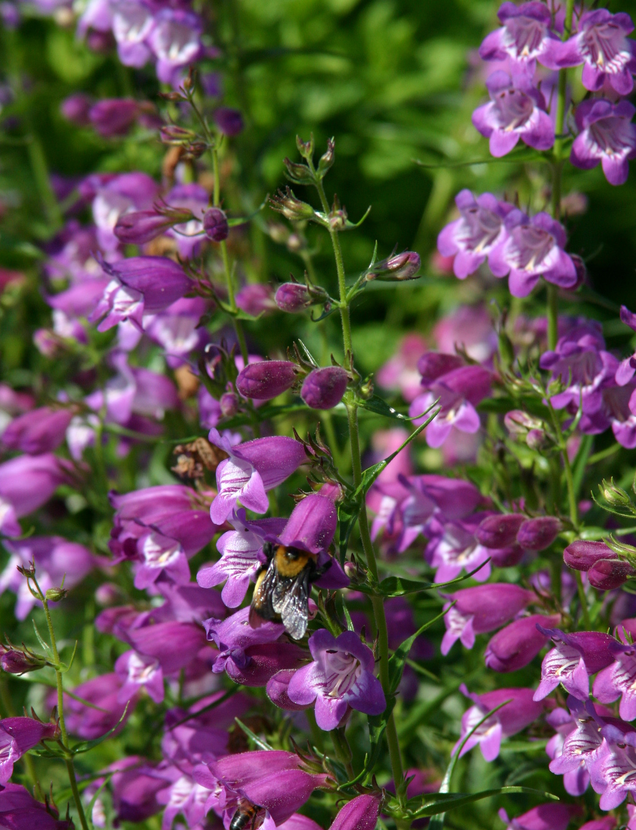
Height: 15”
Width: 12”
Blooms: June to August
Sun: Full sun to partial shade
Water: Moderate
Hardiness: USDA zones 4b-8
Culture: Average soil
Introduced: 1999
Perennial
Durable hybrid penstemons selected from crosses made by Bruce Meyers between Mexican and American wild penstemons. Narrow, dark green leaves form an attractive mound. Red Rocks® sports a constant succession of bright rose flowers all summer, while Pikes Peak Purple® chimes in with violet purple. Both thrive in a range of sites and soils

Pikes Peak Purple® Penstemon
Penstemon x mexicali ‘P007S’
www.plantselect.org

