
Pikes Peak Purple® Penstemon
Penstemon x mexicali ‘P007S’







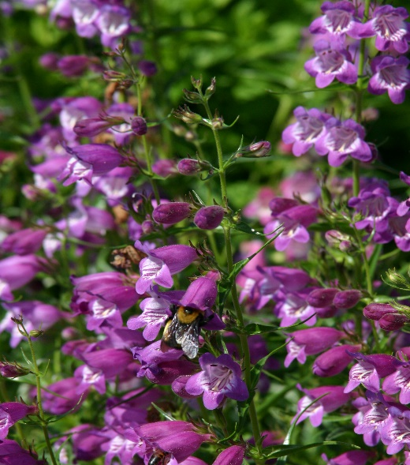

Height: 14-18 in. Width: 12-14 in.
Durable hybrid penstemons selected from crosses made by Bruce Meyers between Mexican and American wild penstemons. Narrow, dark green leaves form an attractive mound. Pikes Peak Purple® offers a constant succession of violet purple flowers all summer.
Culture: Clay, loam or sandy soil
Hardiness: USDA zones 4b-8



WIND. HAIL. SNOW. SUN
BRING IT ON

www.plantselect.org



