



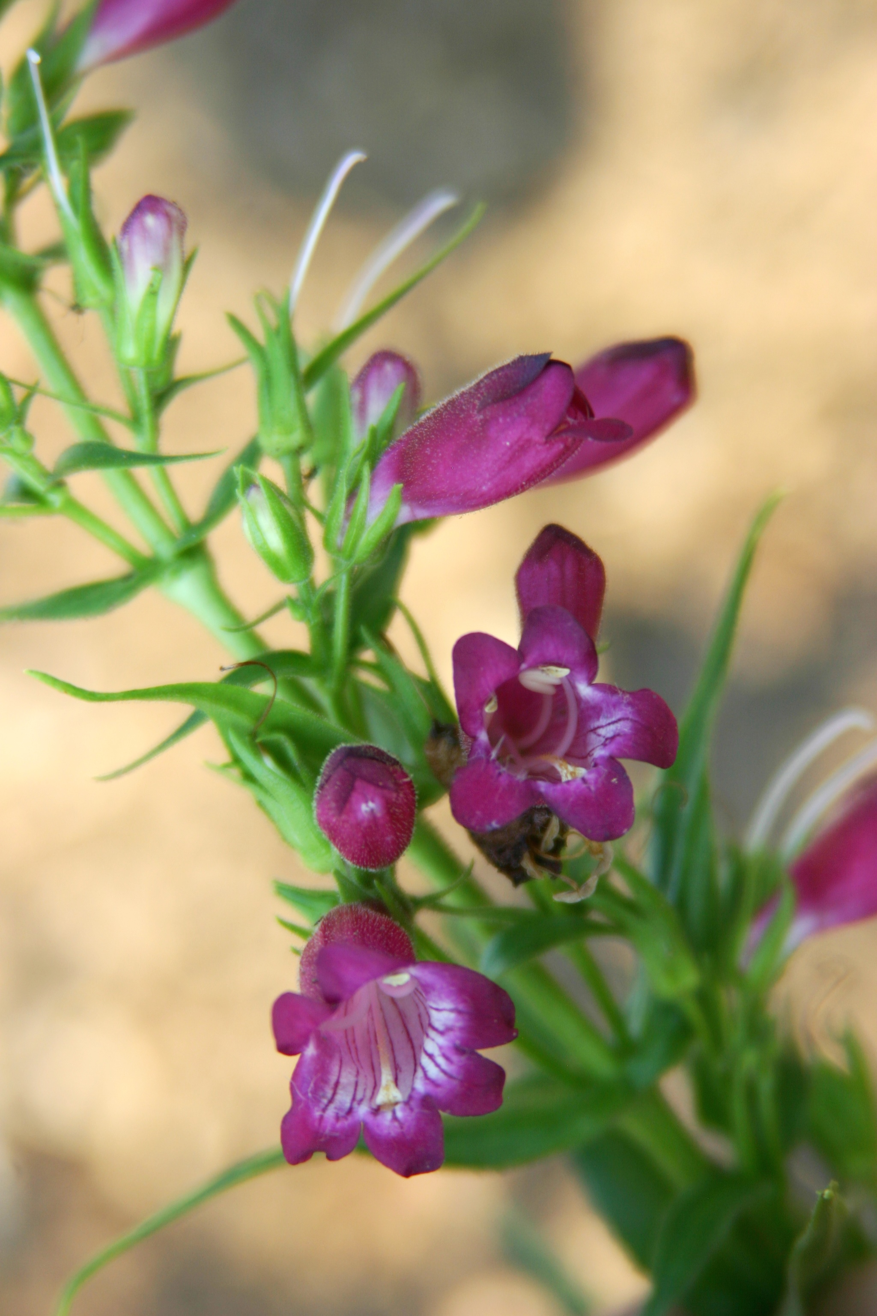
Height: 15”
Width: 12-15”
Blooms: Garnet, summer
Sun: Full sun to part shade
Water: Moderate
Hardiness: USDA zones 4b-8
Culture: Clay, loam or sandy soils
Introduced: 2014
Perennial
Ruby-red or garnet-colored tubular flowers with striped throats nearly all summer long. Narrow, glossy green leaves form an attractive mound. This selection is a hybrid between Mexican and American wild penstemons developed by Kelly Grummons.

Windwalker® Garnet Penstemon
Penstemon x mexicali ‘PWIN02S’
www.plantselect.org

