

**Carolyn’s Hope Pink Penstemon**

*Penstemon x Mexicali ‘*Carolyn’s Hope’ PPAF

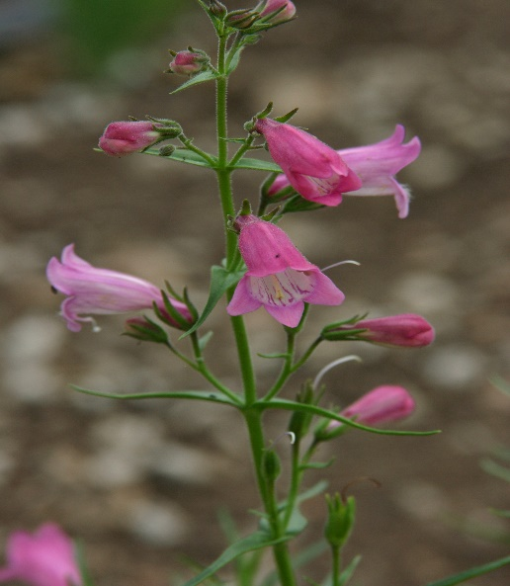

**Height: 14-18 in. Width: 12-14 in.**

Medium pink, tubular flowers with white throats and dark pink buds nearly all summer long. Narrow, glossy green leaves form an attractive mound. This plant was developed by Brian Core in honor of his wife. A portion of proceeds from all sales benefit breast cancer research.

**Culture:** Clay, loam or sandy soil

**Hardiness:** USDA zones 4b-8



WIND. HAIL. SNOW. SUN

**BRING IT ON**

www.plantselect.org

