



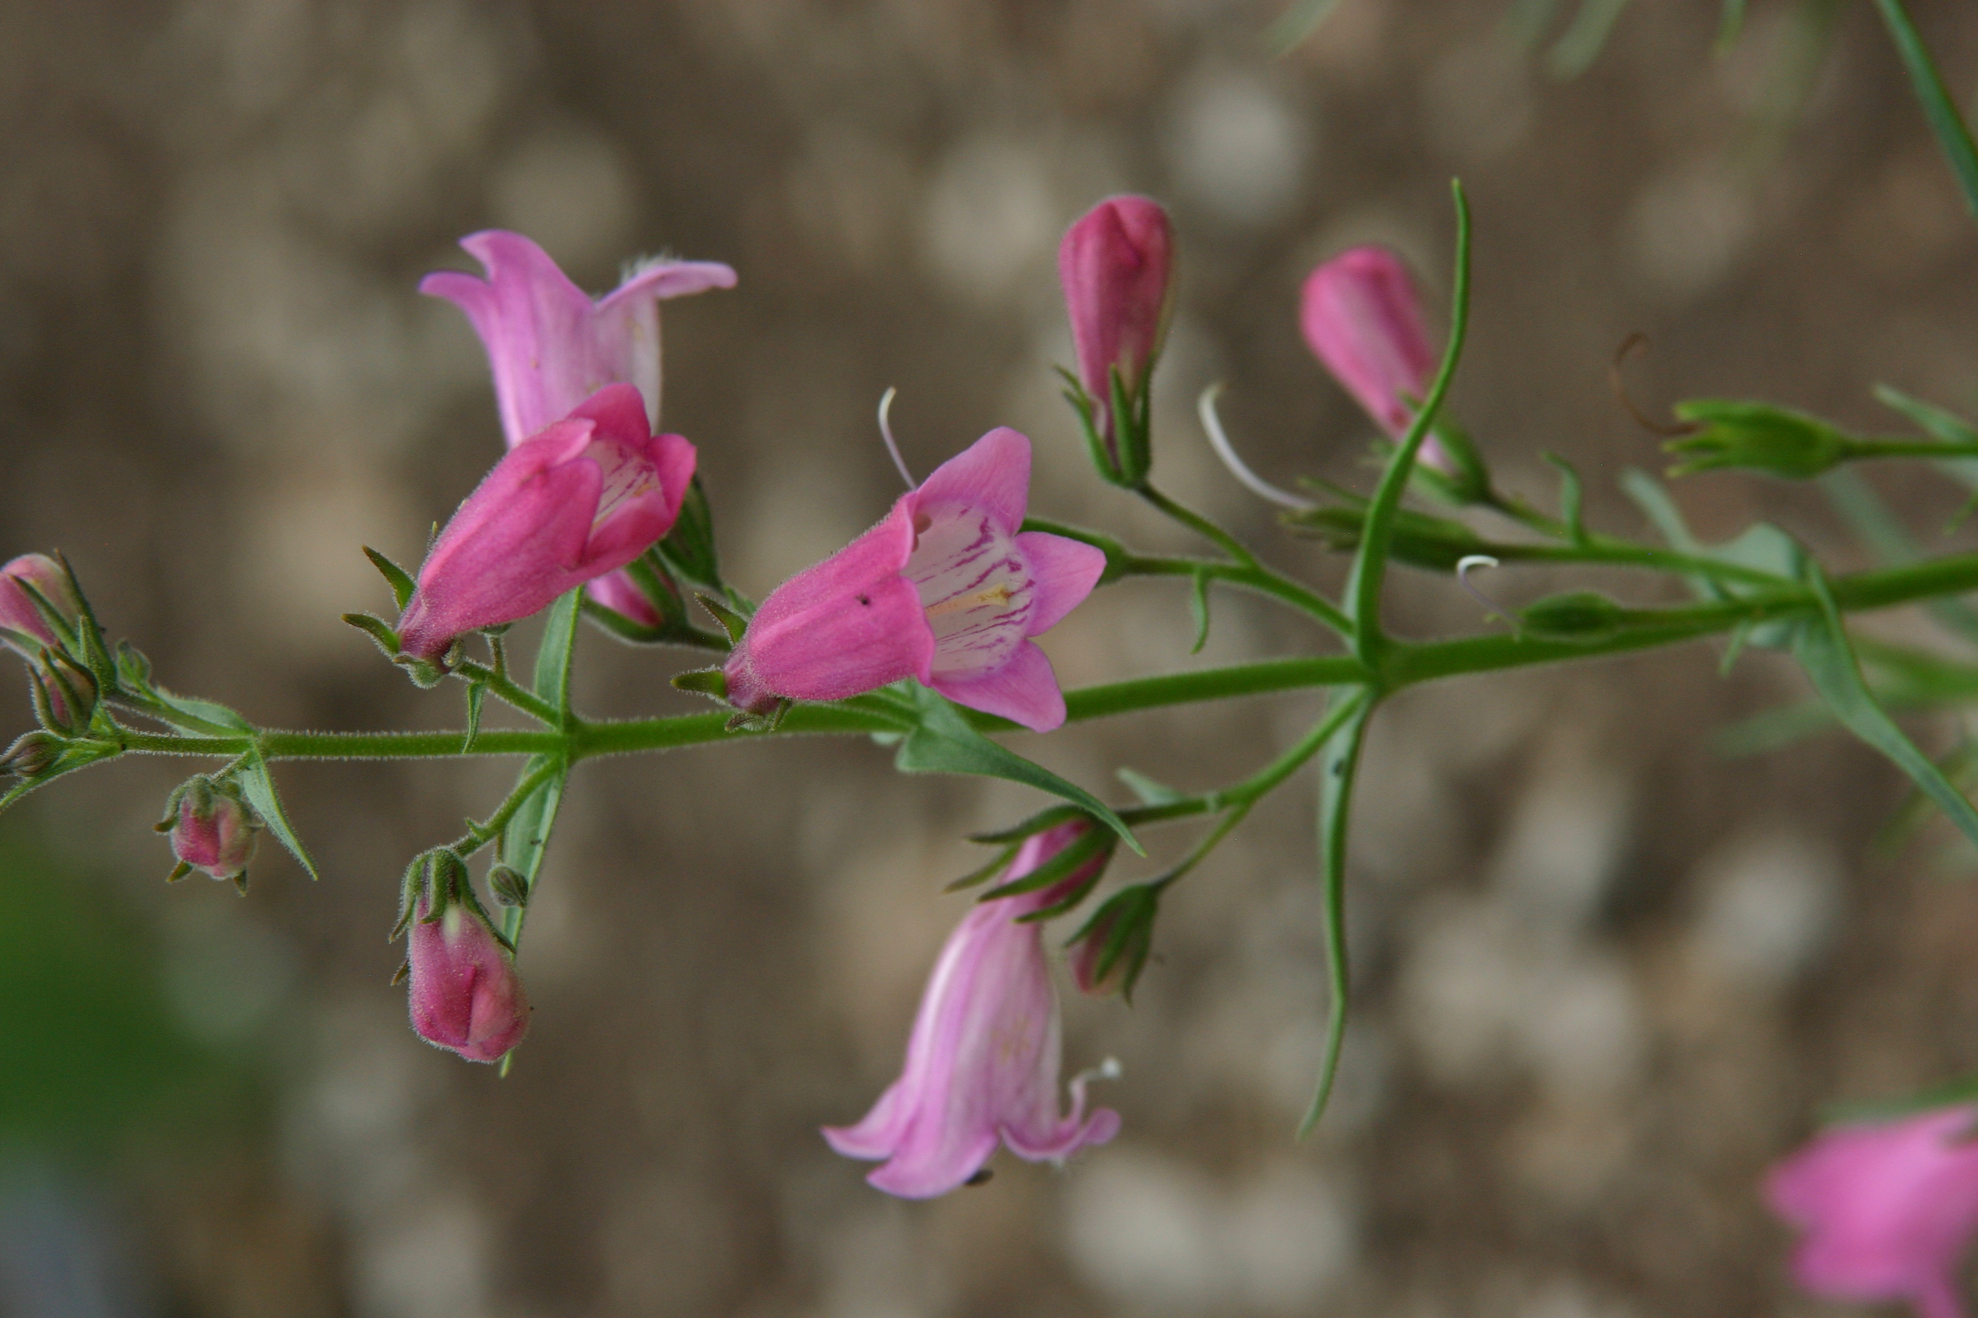
Height: 15”
Width: 12-15”
Blooms: Pink, summer
Sun: Full sun to part shade
Water: Moderate
Hardiness: USDA zones 4b-8
Culture: Clay, loam or sandy soils
Introduced: 2014
Perennial
Medium pink, tubular flowers with white throats and dark pink buds nearly all summer long. Narrow, glossy green leaves form an attractive mound. Hybrid between Mexican and American wild penstemons, this plant was developed by Brian Core in honor of his wife. A portion of proceeds from all sales benefit breast cancer research.

Carolyn’s Hope Pink Penstemon
Penstemon x Mexicali ‘Carolyn’s Hope’ ^{PPAF}
www.plantselect.org

