
Coral Baby penstemon
Penstemon x ‘Coral Baby’

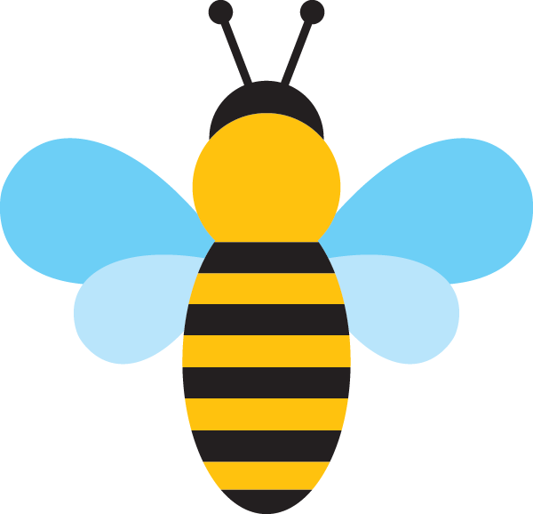
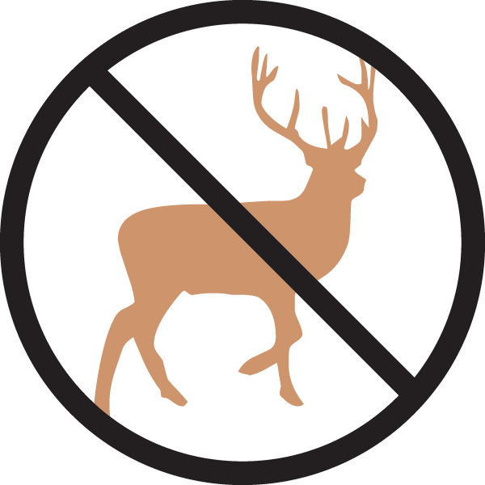



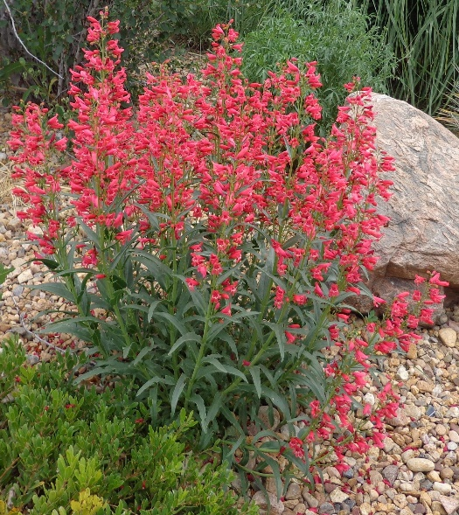

Height: 16-20 in. Width: 12-14 in.
Coral Baby penstemon sports bouquets of coral-pink flowers from May to July. The upright spikes of flower are beautiful in a dry border or rock garden. Coral baby is a favorite of hummingbirds, bees and butterflies and will provide years of enjoyment.
Culture: Well-drained sandy soil
Hardiness: USDA zones 5-8



WIND. HAIL. SNOW. SUN
BRING IT ON

www.plantselect.org



