

**Coral Baby penstemon**

*Penstemon x ‘Coral Baby’*

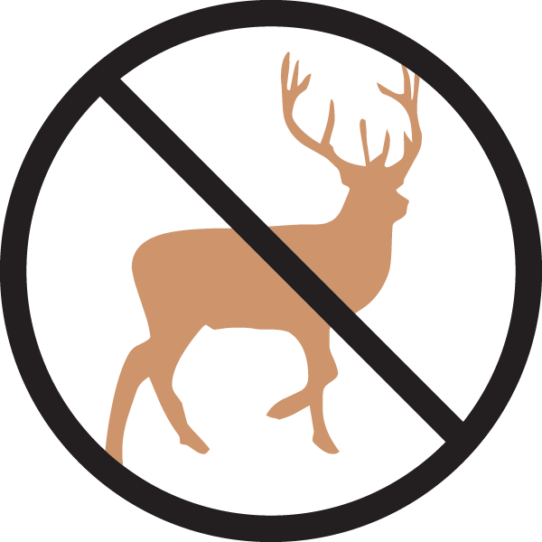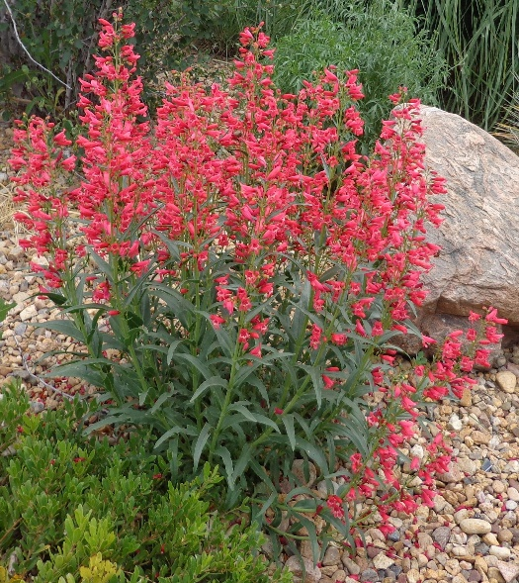

**Height: 16-20 in. Width: 12-14 in.**

Coral Baby penstemon sports bouquets of coral-pink flowers from May to July. The upright spikes of flower are beautiful in a dry border or rock garden. Coral baby is a favorite of hummingbirds, bees and butterflies and will provide years of enjoyment.

**Culture:** Well-drained sandy soil

**Hardiness:** USDA zones 5-8



WIND. HAIL. SNOW. SUN

**BRING IT ON**

www.plantselect.org

