

**Bridges’ Penstemon**

*Penstemon rostriflorus*

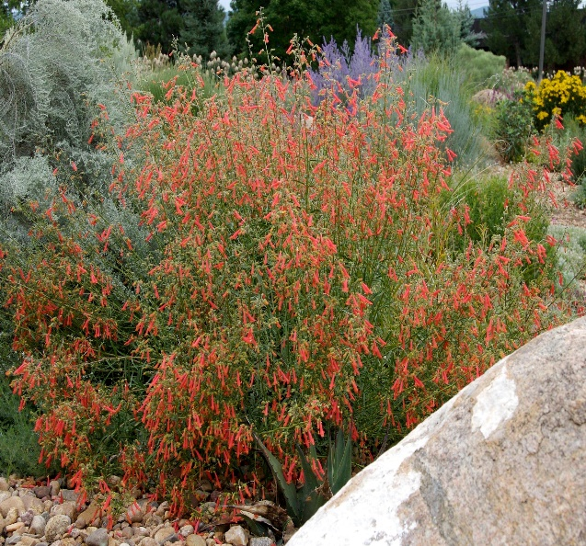

**Height: 28-32 in. Width: 24-30 in.**

Dark evergreen foliage covered with a constant succession of scarlet trumpet flowers through the hot summer months. Long-lived and durable under a wide range of climatic conditions. Little known Southwestern native wildflower.

**Culture:** Clay, loam or sandy soil

**Hardiness:** USDA zones 4b-8



WIND. HAIL. SNOW. SUN

**BRING IT ON**

www.plantselect.org

