



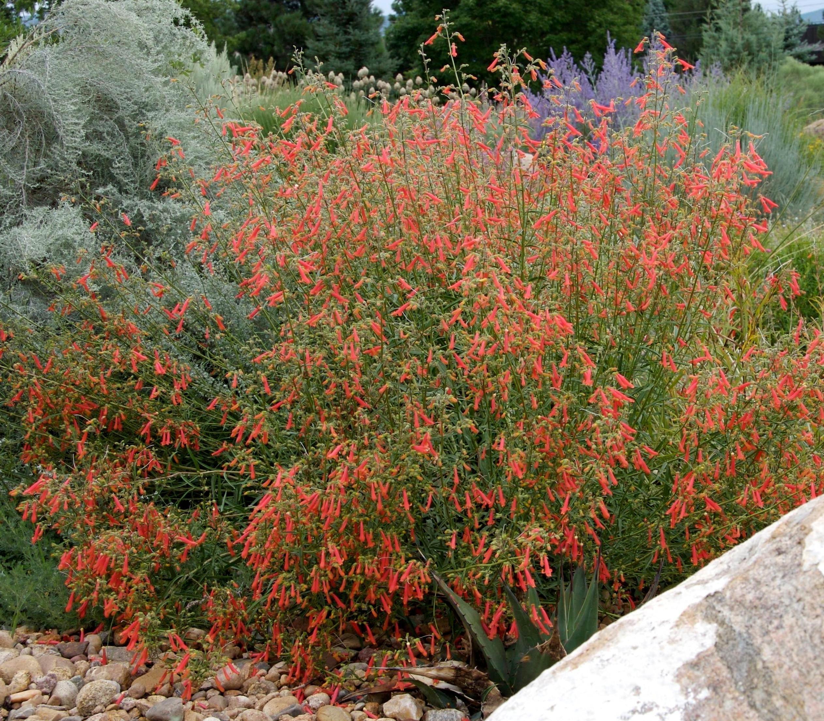
Height: 24-36”
Width: 24-36”
Blooms: Midsummer to fall
Sun: Full sun to partial shade
Water: Moderate to very dry
Hardiness: USDA zones 4b-8 (up to 7,000’)
Culture: Average, clay, or sandy soil
Introduced: 2006
Perennial
Dark evergreen foliage covered with a constant succession of scarlet trumpet flowers through the hot summer months. Long-lived and durable under a wide range of climatic conditions. Little known Southwestern native wildflower.

Bridges’ Penstemon
Penstemon rostriflorus
www.plantselect.org

