
Desert Beardtongue
Penstemon pseudospectabilis


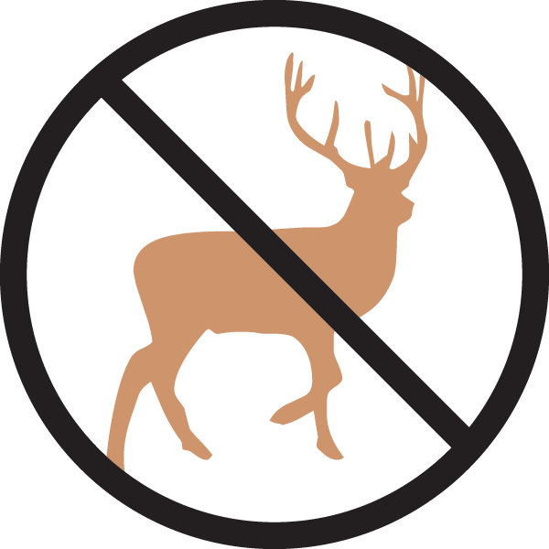




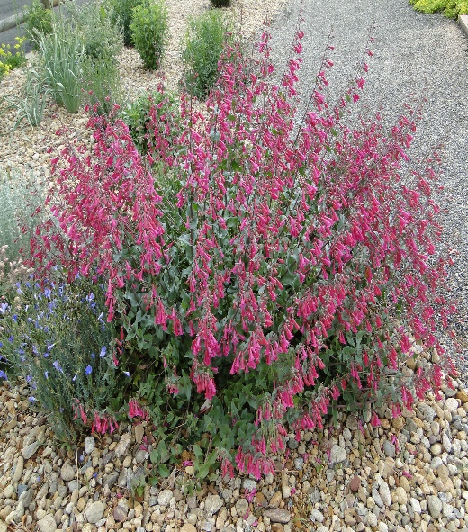

Height: 28-32 in. Width: 14-18 in.
Mounds of deep blue-green foliage are topped with vivid purple-magenta trumpets for much of the growing season. This long-lived perennial attracts hummingbirds in daylight and hawkmoths at dusk.
Culture: Clay or sandy soil
Hardiness: USDA zones 5-9



WIND. HAIL. SNOW. SUN
BRING IT ON

www.plantselect.org

