

**Desert Beardtongue**

*Penstemon pseudospectabilis*

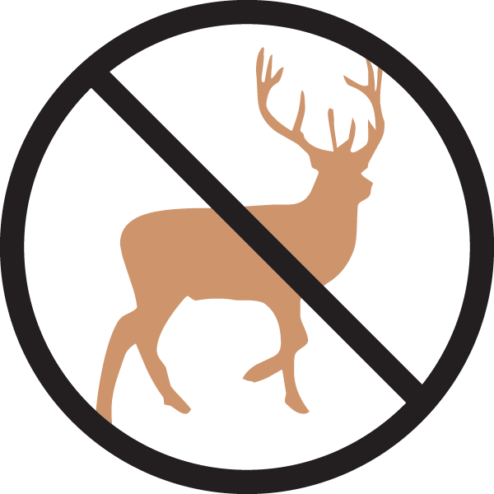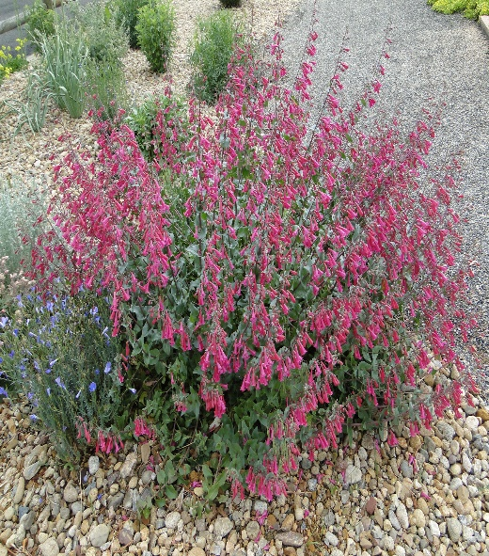

**Height: 28-32 in. Width: 14-18 in.**

Mounds of deep blue-green foliage are topped with vivid purple-magenta trumpets for much of the growing season. This long-lived perennial attracts hummingbirds in daylight and hawkmoths at dusk.

**Culture:** Clay or sandy soil

**Hardiness:** USDA zones 5-9



WIND. HAIL. SNOW. SUN

**BRING IT ON**

www.plantselect.org

